Three Way Tandem Turnout

Not all turnout combinations are possible as three conditions must be met:
a) there must be at least 11 inches scale space (Gauge face to gauge face) for the second point blade to open behind the first one. This allows space for the slide chair on the second point blade and a bridge chair or bolted half-chair on the first one.
Use the RULER tool or spacing ring to measure the space.
b) there must be a least 14 inches scale space either side of the middle V-crossing to allow space for the wing rails and the chairs on the adjacent rails. Sometimes the wing rails are shortened because of this and bolted half-chairs used for running rail.
c) no two V-crossings may be opposite one another, as this prevents the check rails being correctly positioned.

Pictures show the results of the procedures listed following the picture.
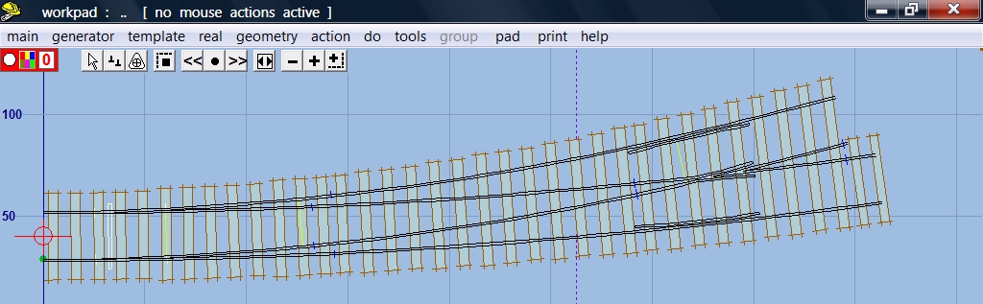

1. This “how to” is done with PUG .091c in S gauge. Start with B8 LH turnout, radius 10 chains. Change the main road curving to 3000 mm radius, timbers square on to main road.
template > new template (quick set)…… > B8 LH turnout – radius 10 chains
Use F6 Curving to set the radius to 3,000 mm. 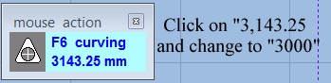
real > timbering > square-on (to main road)
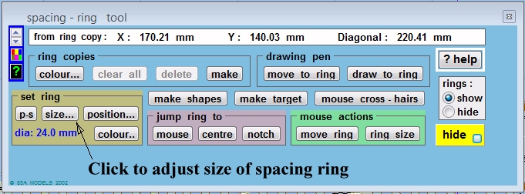
2. Show spacing ring. Click on size…
tools > spacing ring
size
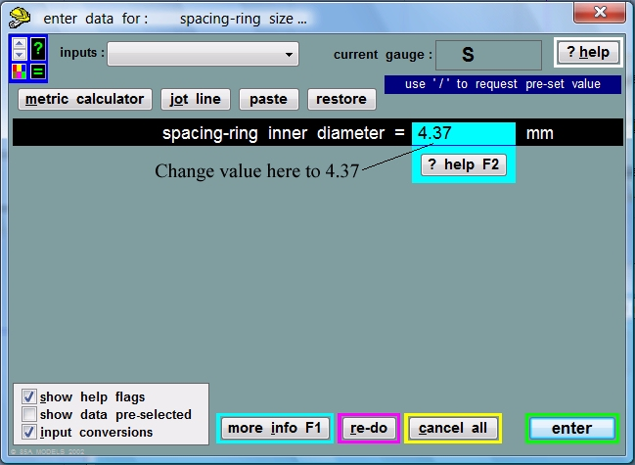
3. Adjust inner diameter to 4.37 mm (11 scale inches in S scale).
4.37, enter and then OK
Note that the spacing ring is initially located at the pad datum.
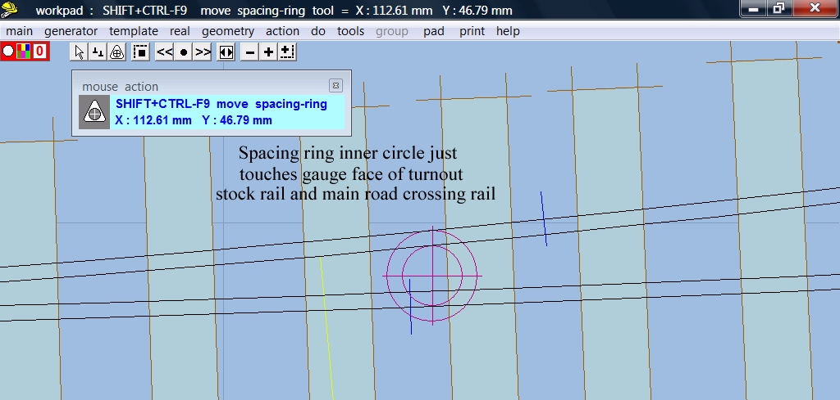
4. Move the spacing ring so that the inner circle just touches the gauge face of the turnout road stock rail and the main road crossing rail.
Action > mouse actions : pad > move spacing ring tool
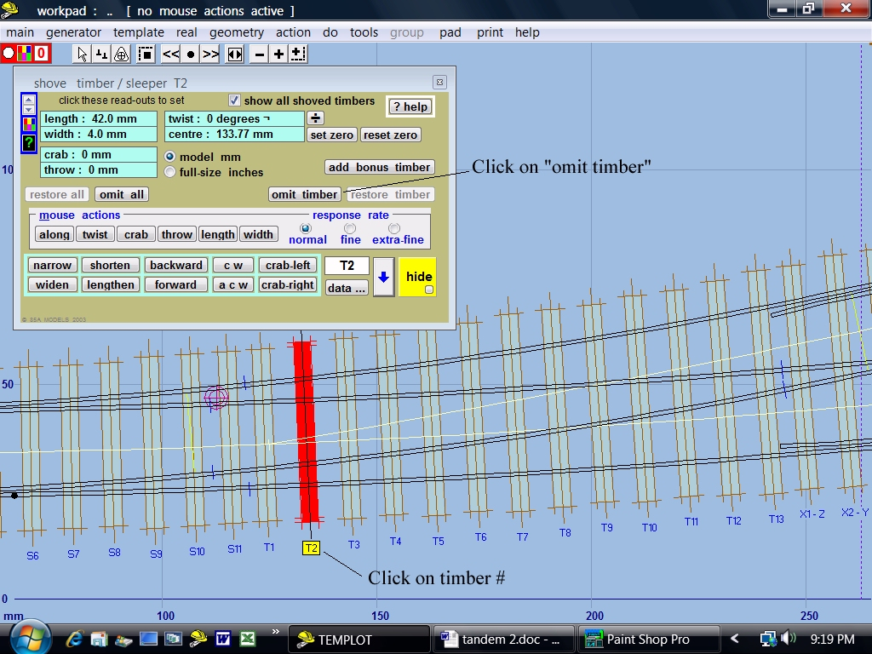
5. Now is the time to omit some timbers so that we can see what we are doing with the second or tandem turnout.
real > timbering > shove timbers
Click on the timber # T2, then on “omit timber” and the timber disappears. We could have started with T1 as the spacing ring shows the points for the second turnout could start on S8. However, Martin’s video shows 14 timbers, consequently we will show 14 timbers.
Each timber must be omitted individually. Omit timbers T2 to X1 2 and X8 to E2 and you will have Turnout 1 to match the video.
Hide the spacing ring as you no longer need it.
main > store & background
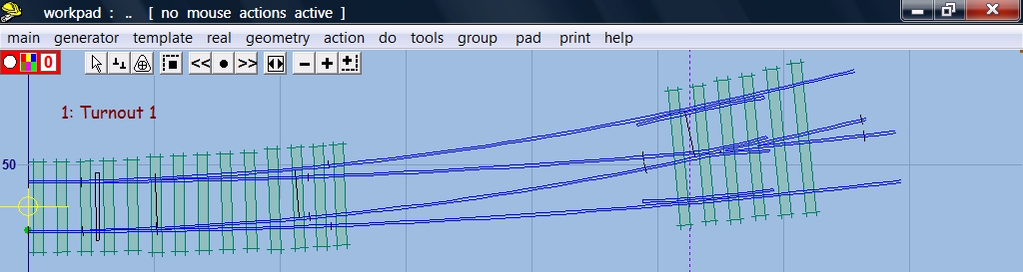
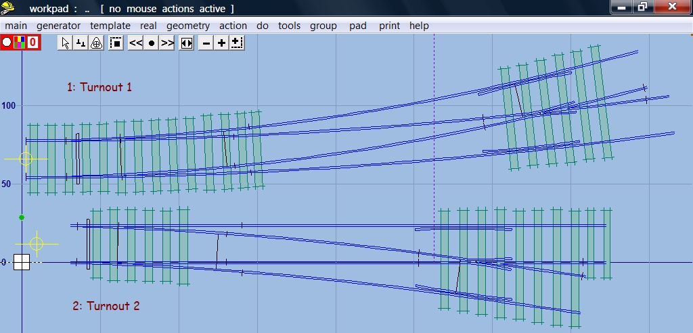
- Now make the second turnout as in sequence 1 aove, a B7, straight, timbering square on to the main road. Name it “Turnout 2”
template > new template (quick set)…… > B7 RH turnout, curving - straight.
Template > switch options…. > BH size A semi-curved flexible switch
do > blank up to switch toe
As in 5 above, omit timbers S1 and S8 to X1-2
Name turnout
main > store & background
At this stage you should have two templates that look like the ones at the beginning of the video.
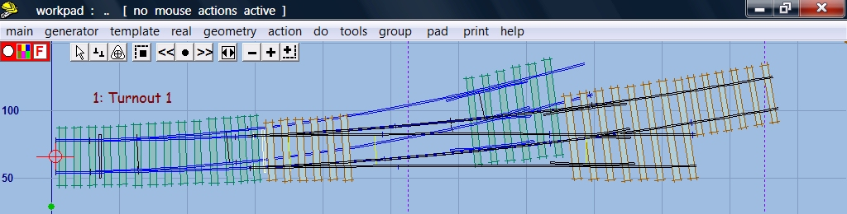
- Left click Turnout 2
delete to control.
Left click on Turnout 1
peg align > align current template over background template > facing – facing. In popup menu leave background template unchanged.
Ctrl – F6 to snake control template along background template until toe is on last timber of background template.
main > store & background.

