GETTING STARTED IN TEMPLOT

This is a short exercise for someone who is completely new to Templot. It goes step by step through all the processes involved in creating a simple track plan, and introduces the functions involved.

It is not a comprehensive guide to Templot, and it is entirely unofficial.

It is hoped that new users will, by actually creating a usable trackplan, develop a facility through actually carrying out the steps involved, and will acquire the confidence to further experiment with the many controls for themselves. The only way to really get to know Templot well is to keep trying different controls to see what they do.

It must be emphasised that there are always several ways of achieving an objective, and this is only one way; it is the way I might operate. I am very well aware that other experienced users will operate in a different way.

This tutorial is intended for those who are completely new to Templot; it will not help those who are already mired in its complications. There is much that is not dealt with atall, and some things that are only touched on. However nothing succeeds like success, and the user who has accomplished this will be able to journey forth into the wide open reaches of the program knowing that it can achieve results.

This document is my personal creation and owes nothing to anyone else.

Allan Ferguson

Open Templot. 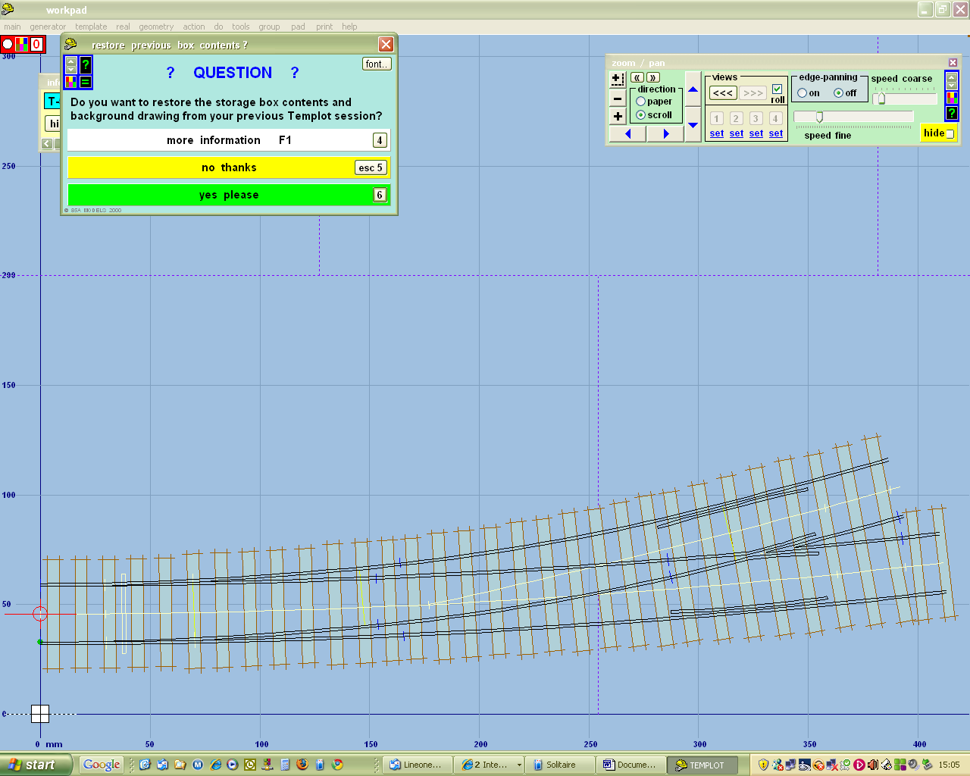

Click no thanks

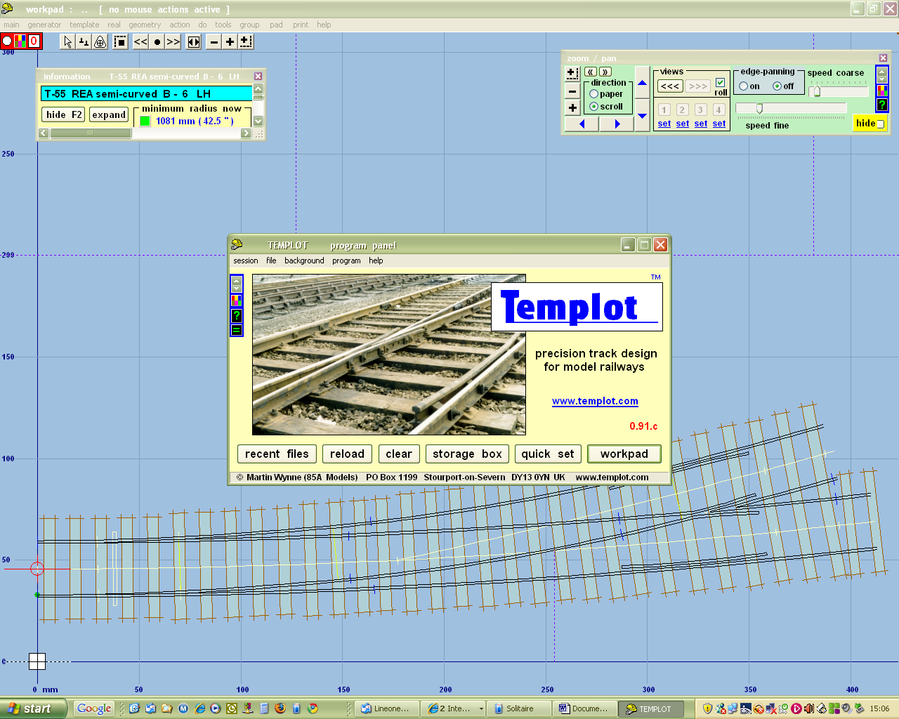

Click workpad

Click Template
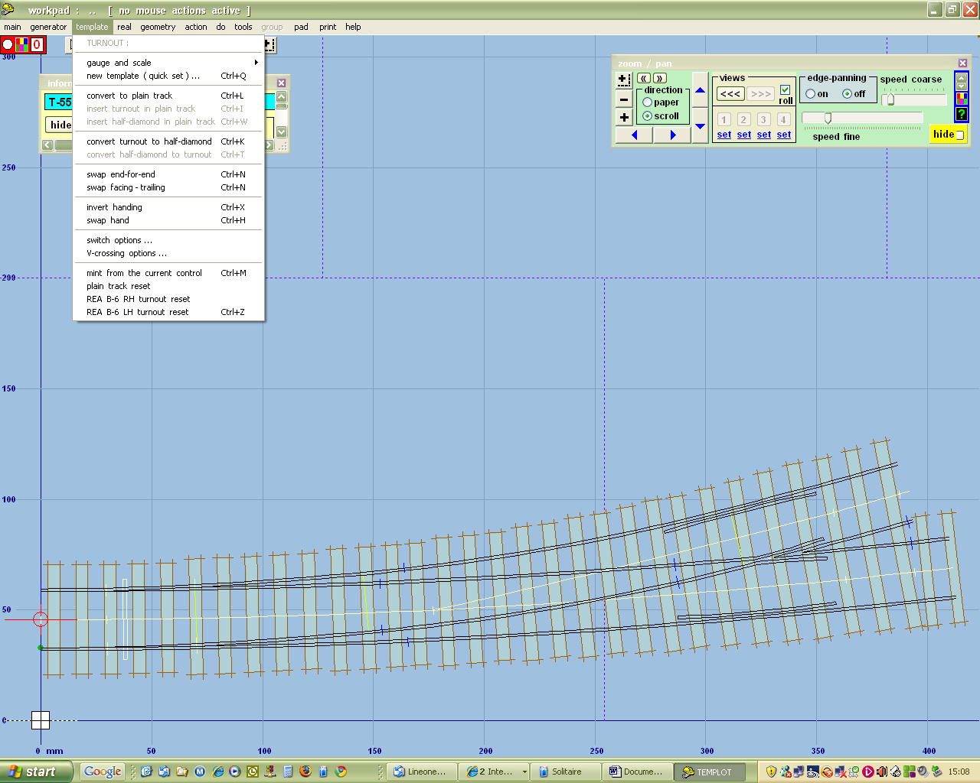

Click Gauge and Scale, then P4/S4 (or whatever scale / gauge combination you use: I model P4)

This converts the turnout on the page to your chosen gauge

Click Template / Convert to plain track

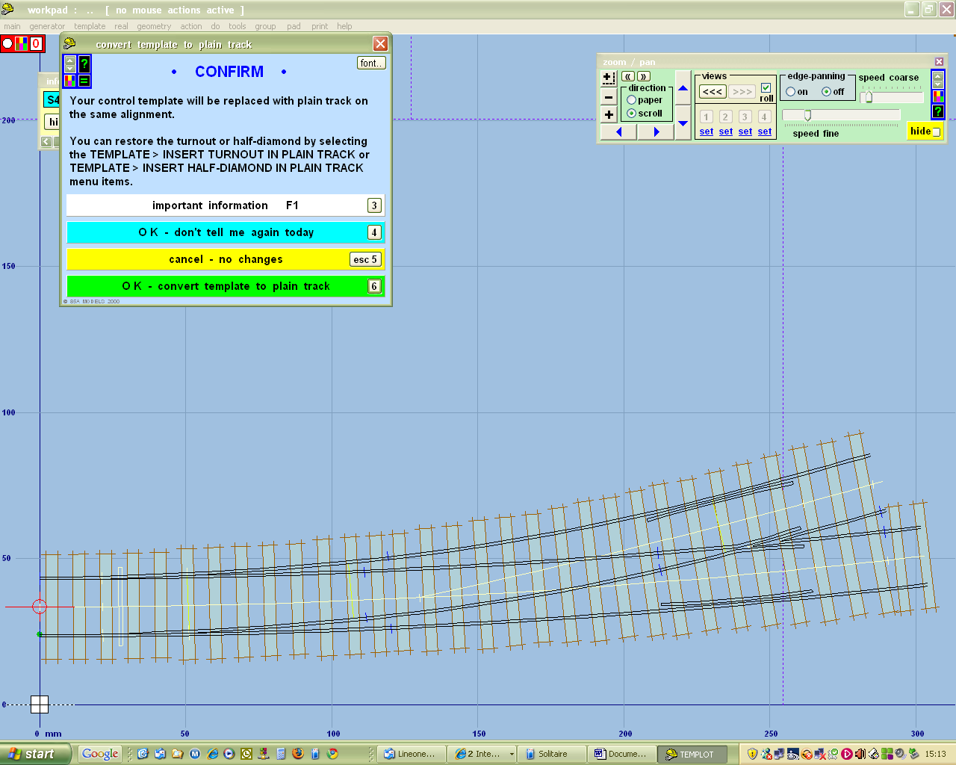

Click OK – don't tell me again today (unless you want to be reminded every time)

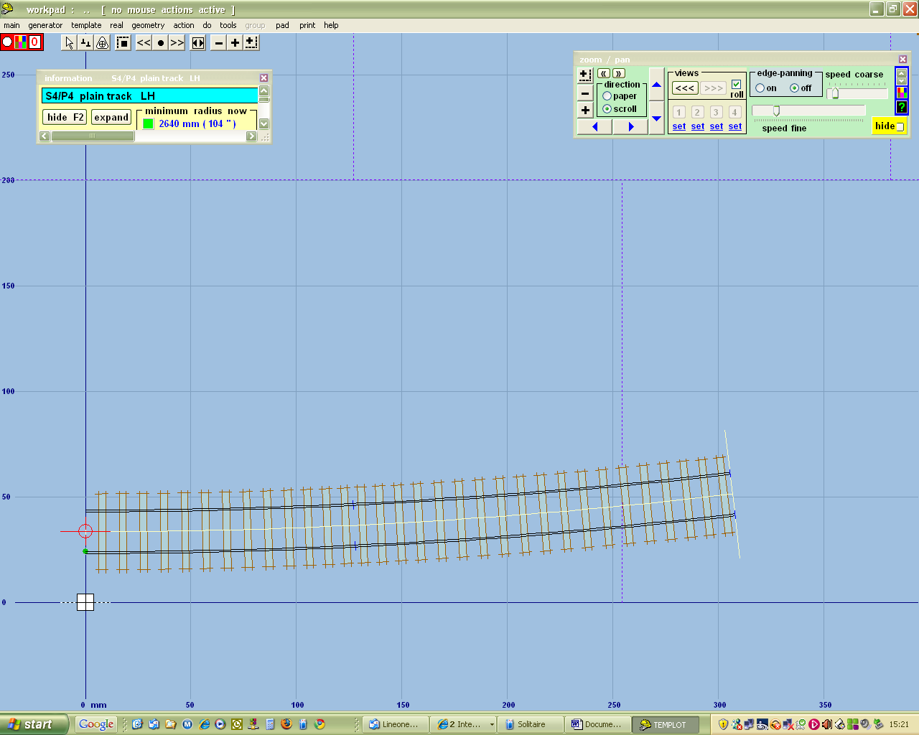

Now zoom out using the panel at top left, or the centre mouse wheel. You can also move the templates around using the mouse

Click F3 or F4, and increase the length of the template using the mouse

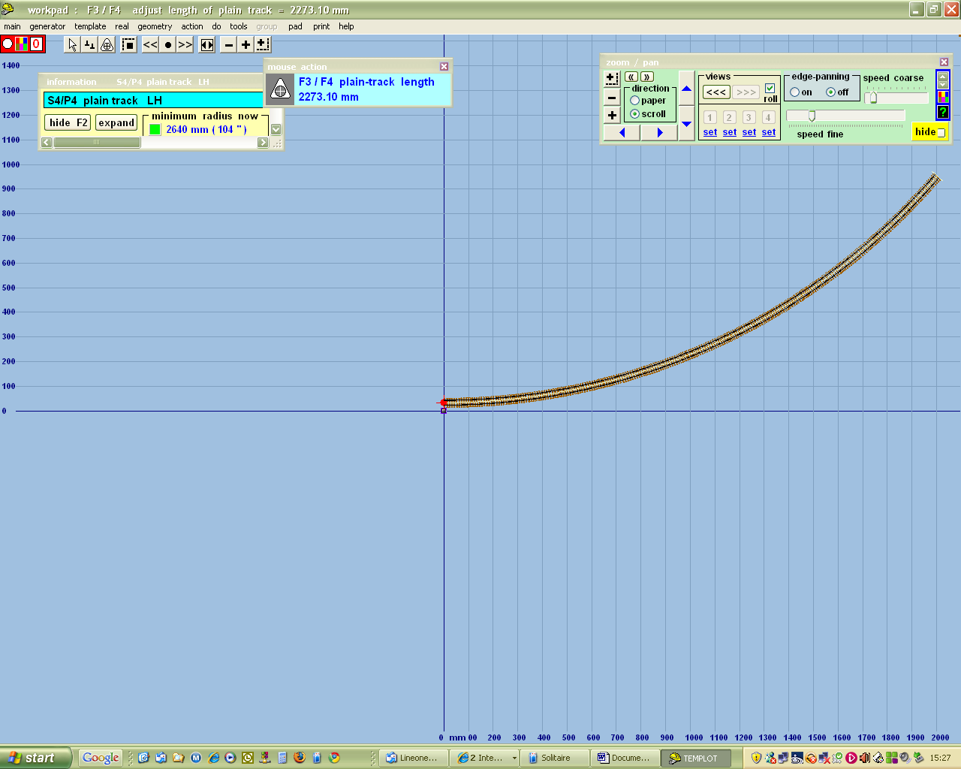

Press F6 and use the mouse to adjust the radius of curvature.
Set it about 6400mm.

Use the mouse to drag the template to the middle of the screen
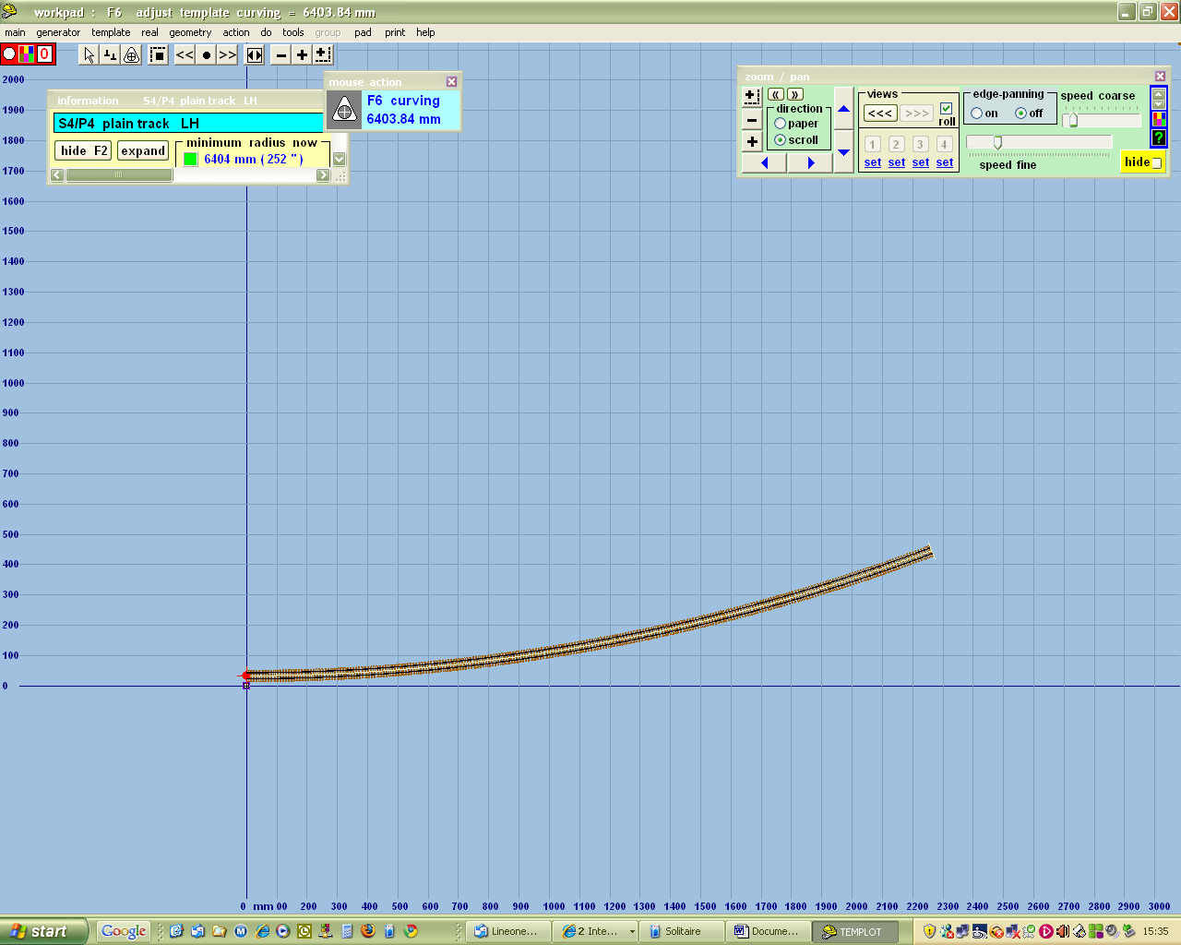

Click on Template / insert turnout in plain track

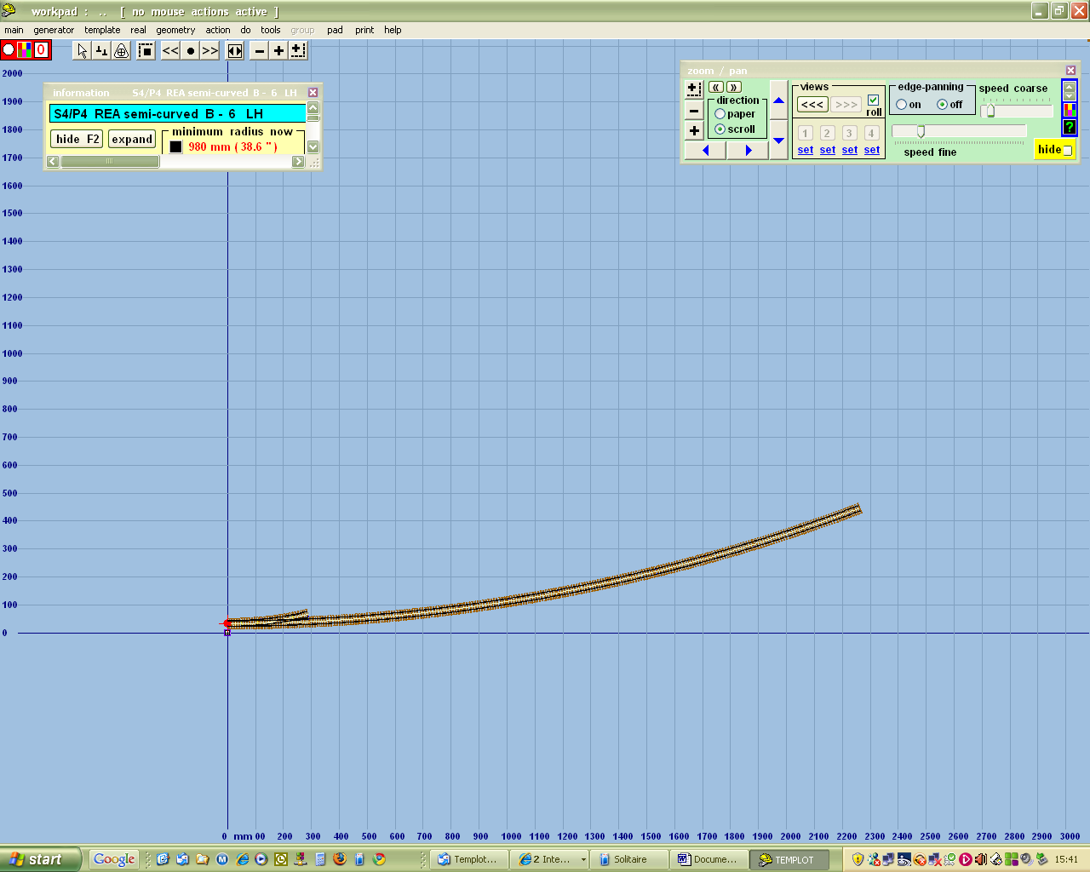

This has given me a turnout B6 left hand. It's also resulted in a minimum radius of 980mm, which is less than I'll accept. Also, as I model pregrouping I want straight cut switches. So click Template / switch options / 12ft straight heel switch / OK
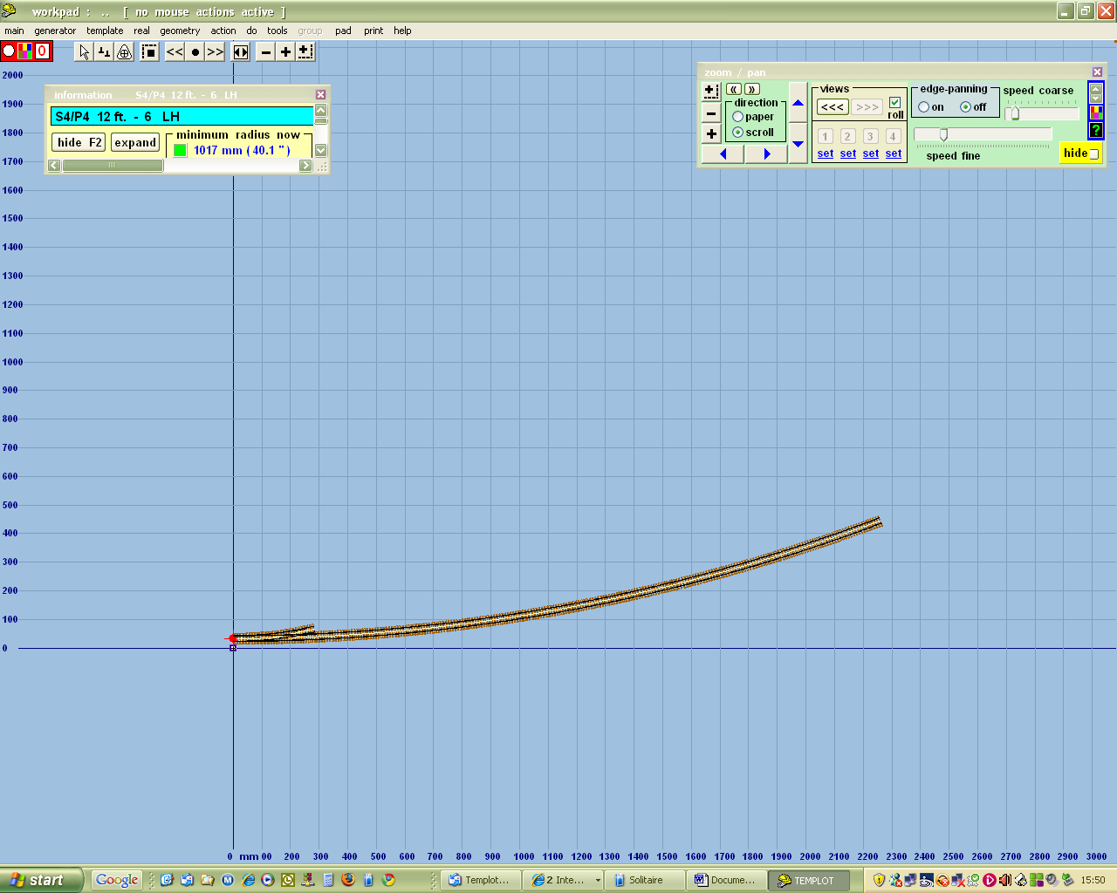

Note that this has already increased the minimum radius. Now click template / V crossing options / 1:8 / OK

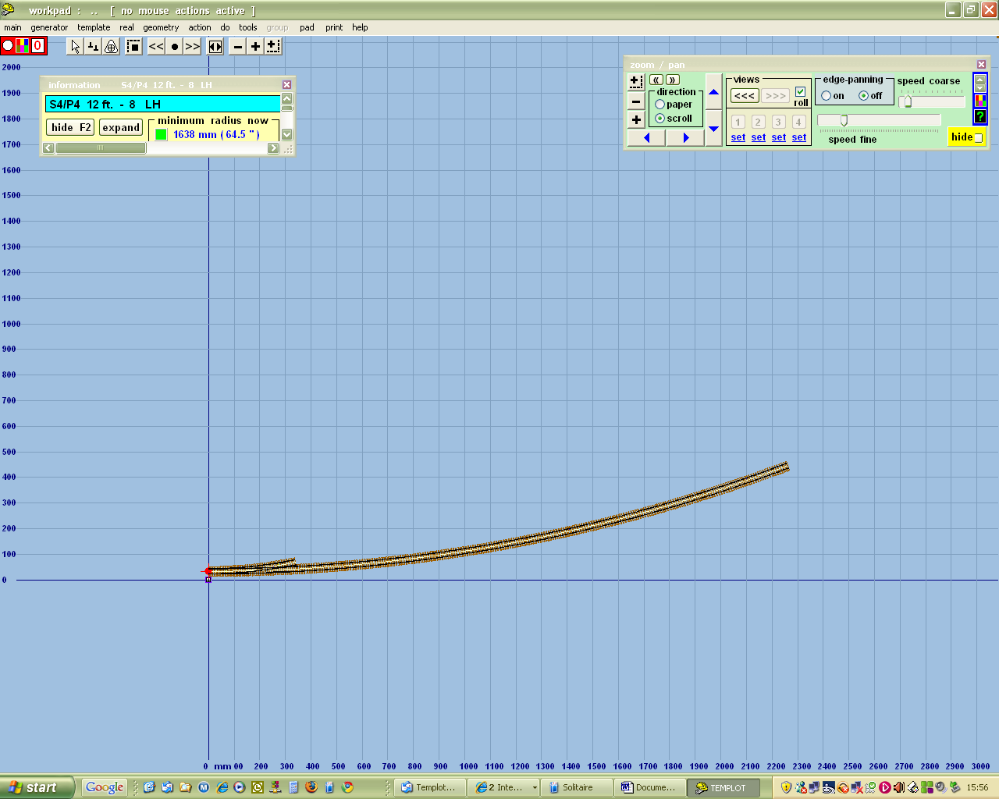

Now this has given me a much longer turnout, with a more acceptable minimum radius. Now I want to move it along a bit, without altering the position of the main line. Press key 9 (not on numeric keypad). This lets me use the mouse to position the turnout just where I want it along the main line.

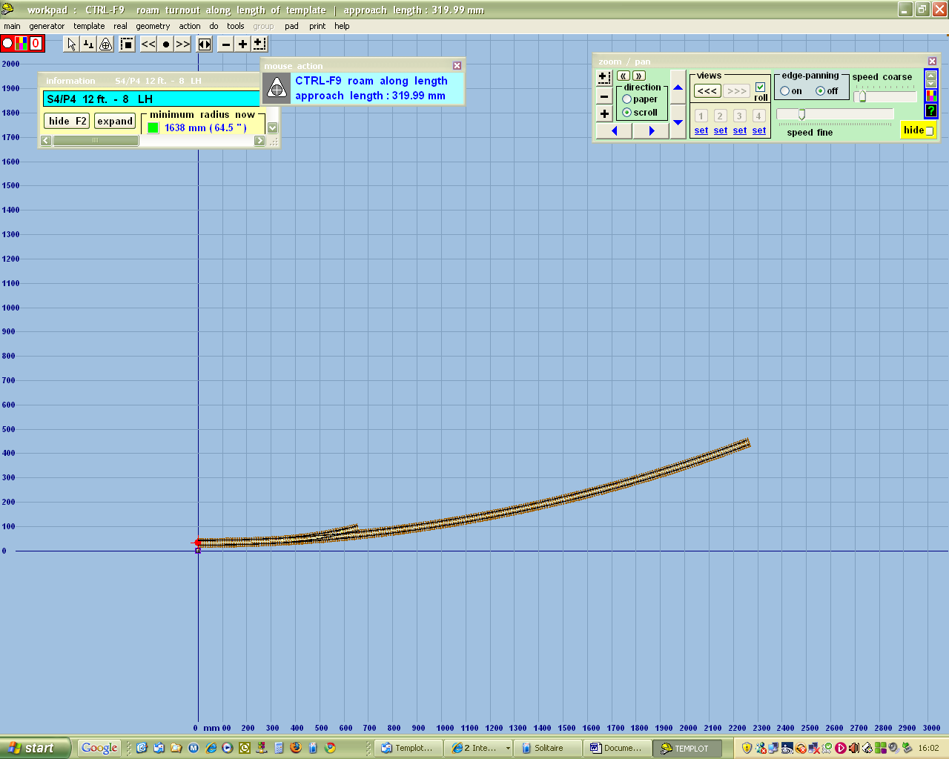

Now I want to turn this into a loop. Click on tools / make simple crossover

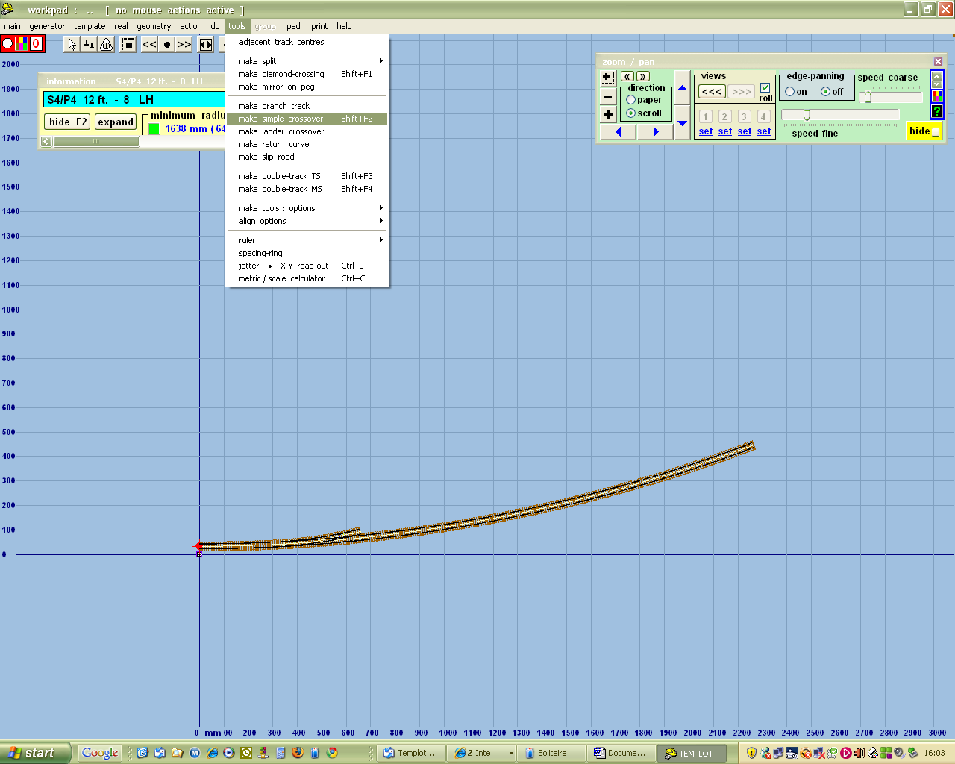

And this will give you something like this

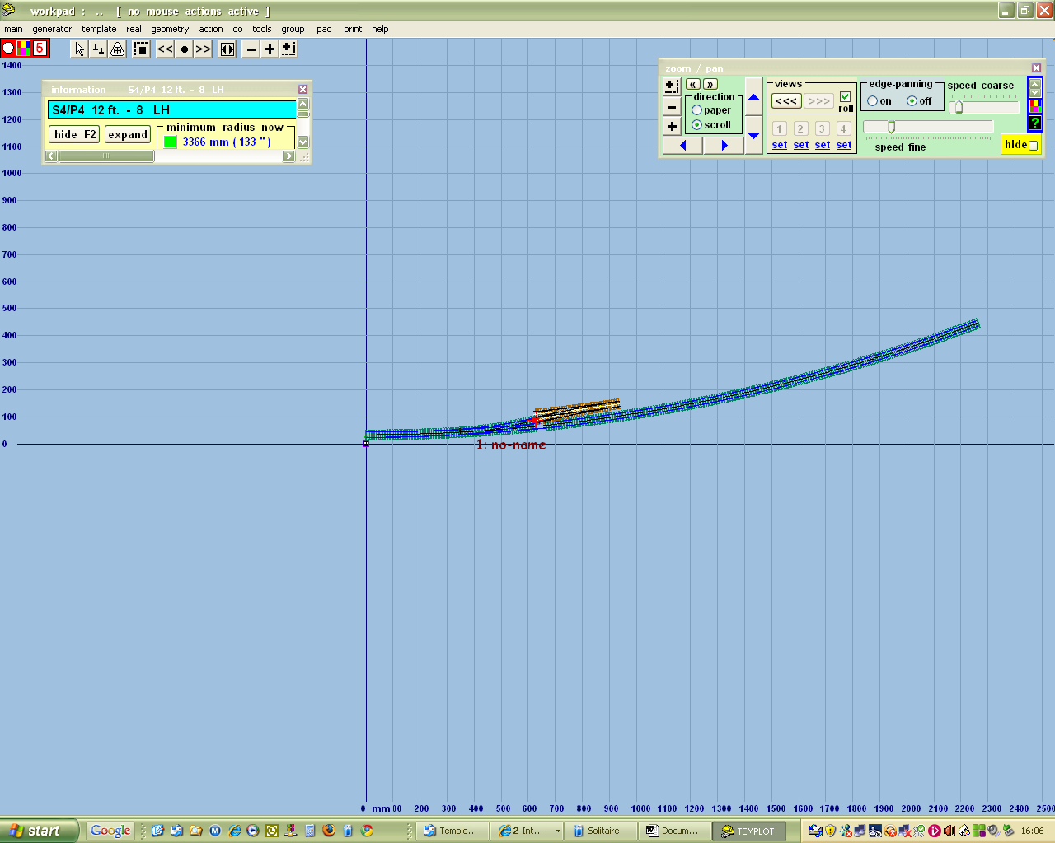

You'll note that you now have two templates, the control template in yellow, and the background template in blue. There is only ever one control template, and it's the one we're working with. Any other templates are background templates. Personally I like to minimise the amount of stuff showing on the screen, so I click pad / background options / background templates detail,

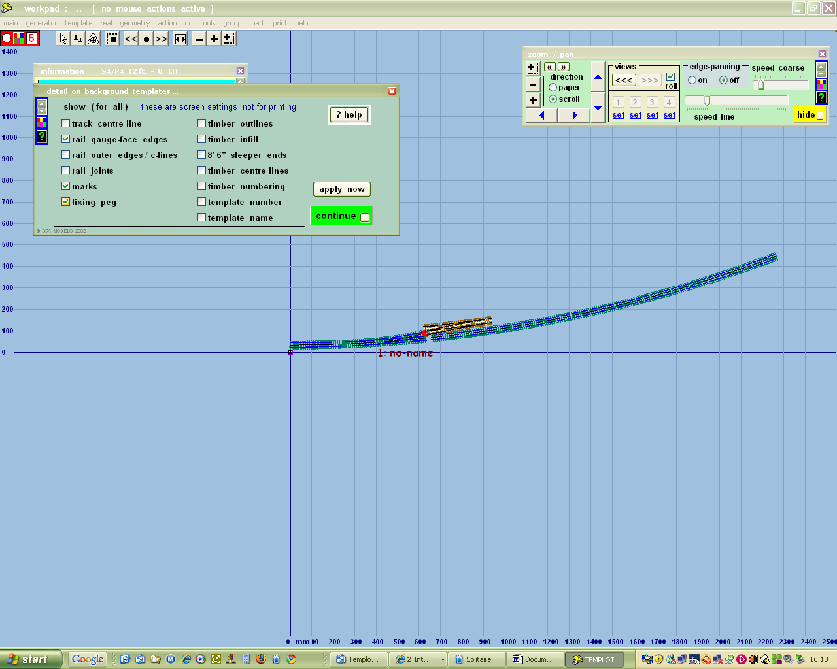

and unclick everything except rail gauge face edges, marks, and fixing pegs. These are the minimum I need to work with; the rest can be brought back if I want them.

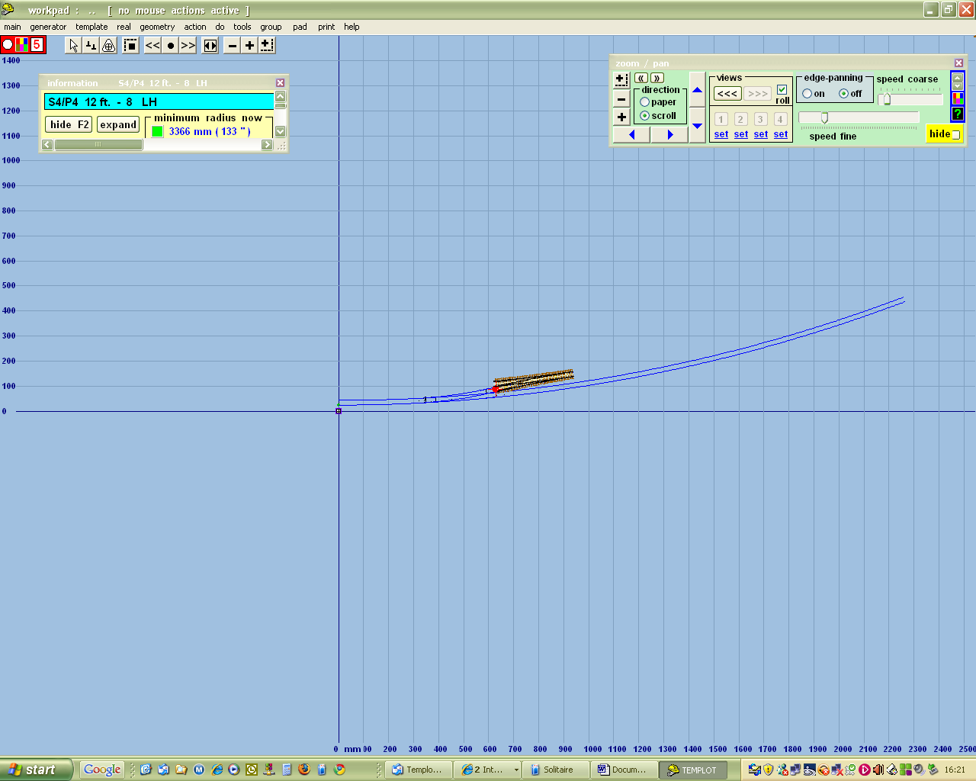

The red dot is the peg for this template which may be thought of as the handle by which it is moved around., and from which things happen. So as I want to extend my embryo loop, press F3 (approach length) and use the mouse to extend the approach as required.

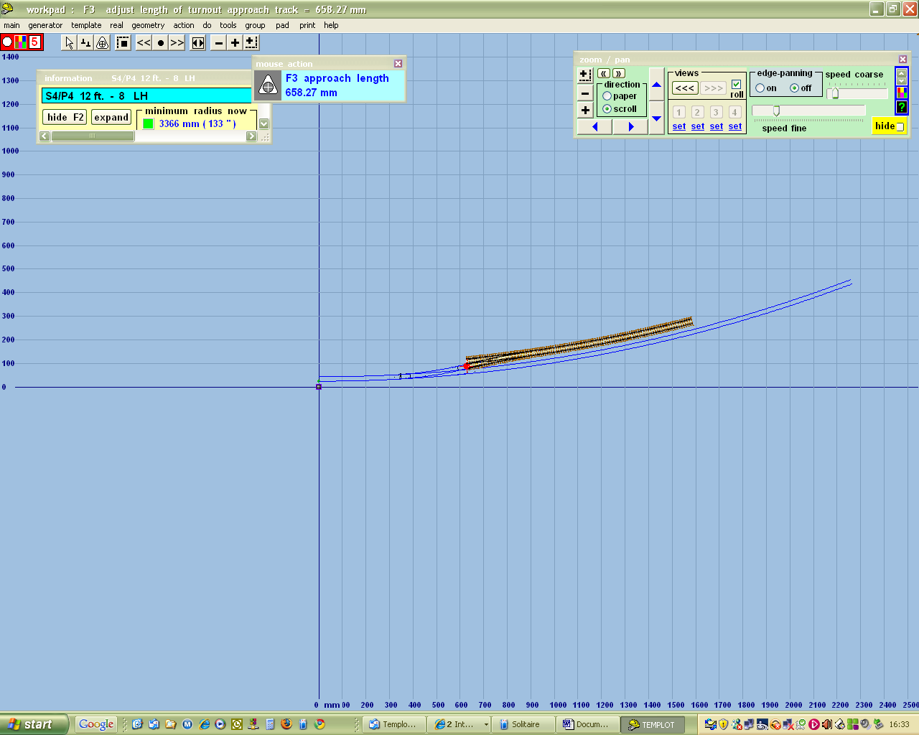

Notice that the new bit of track is on a parallel curvature to the previous bit. Now I want to extend the headshunt, so press F4 and use the mouse to extend the overall length of the turnout as required.
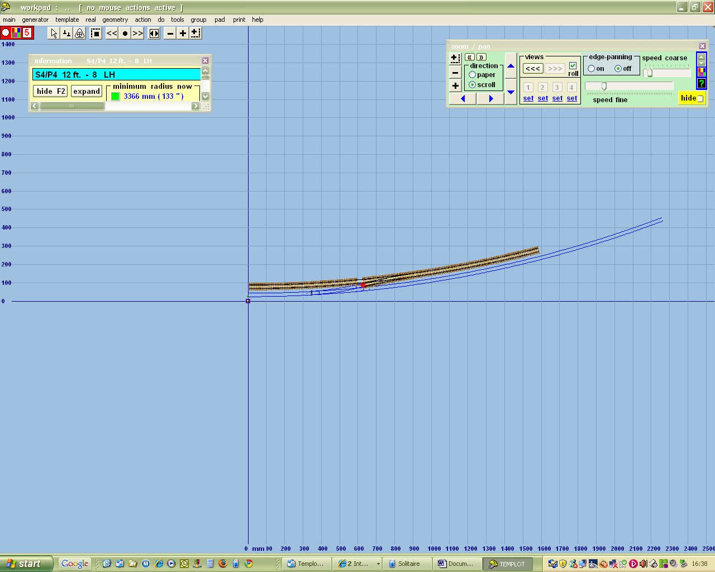

I would like to curve the headshunt on a different radius, so I first need to separate it from the rest of the template, using tools / make split / make separate exit track

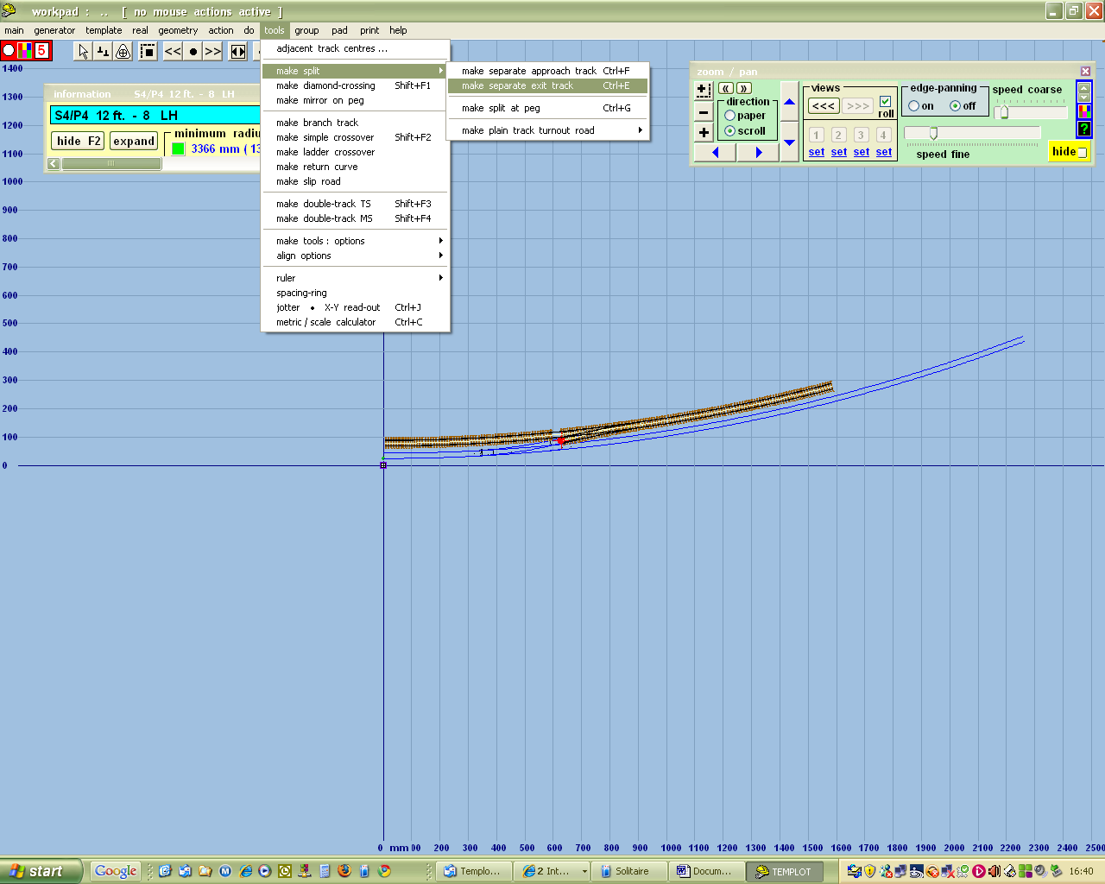

This creates a new template which I can deal with by itself, in this case by reducing the radius slightly
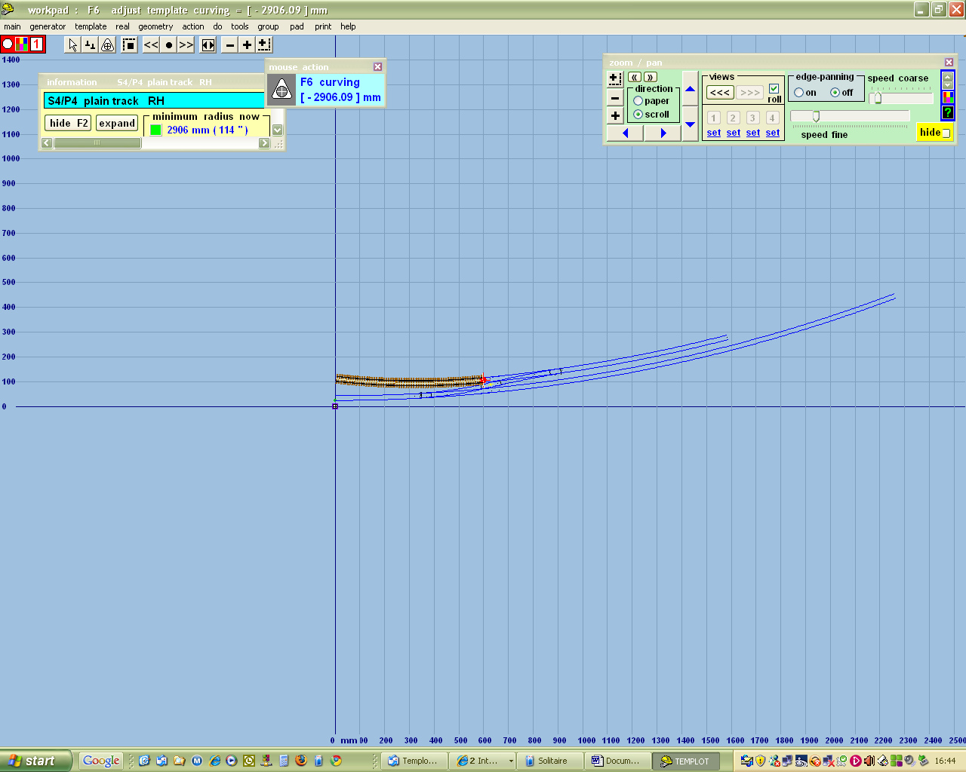

Note the position of the peg. If it had been at the other end this is what would have happened

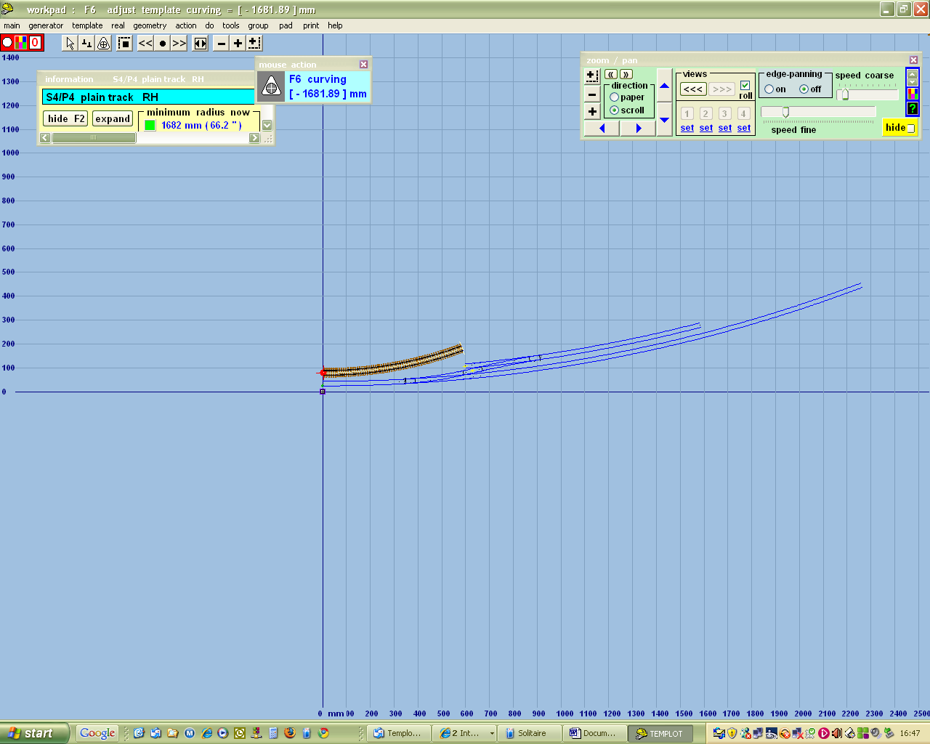

The peg position can be changed by clicking in the box with the number in it at top left, or by clicking on geometry / peg positions / …..

Now I want to create the other end of the loop, so I first have to transfer this template to the background. Right click anywhere on the screen, then left click on store and background.

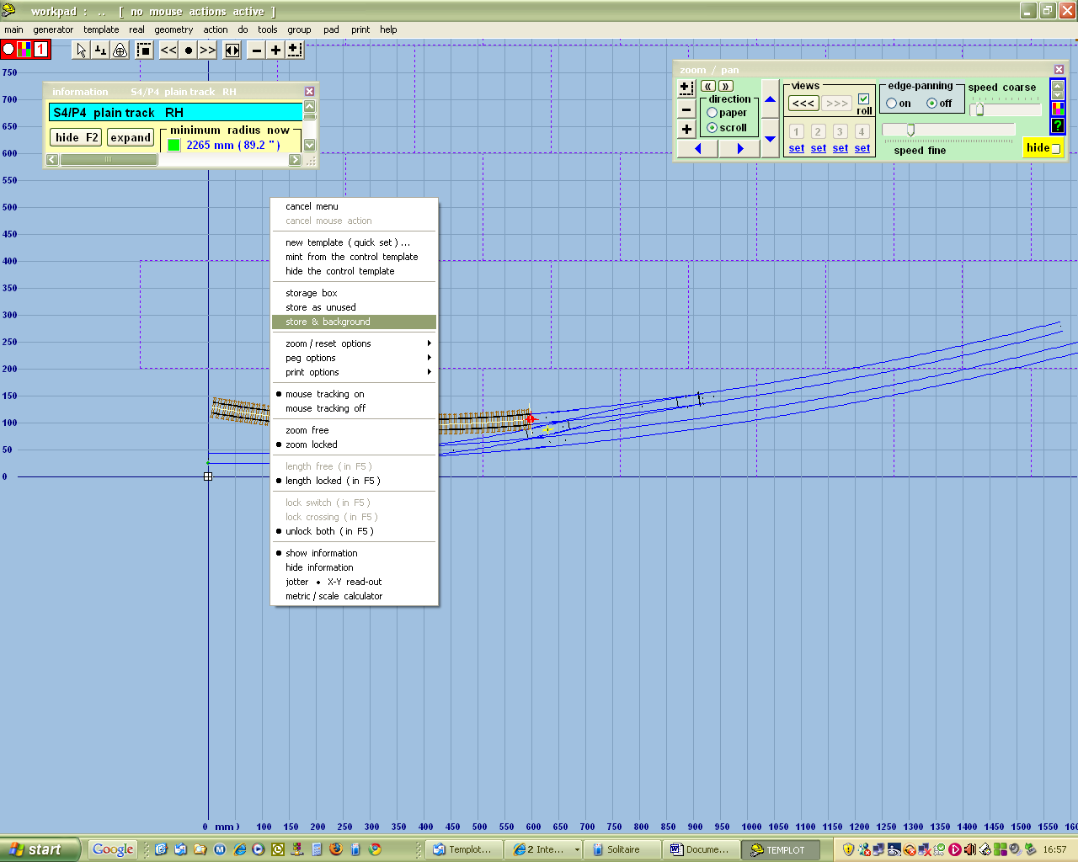

To put in the other end of the loop I need another crossover. Start by left clicking on the loop line

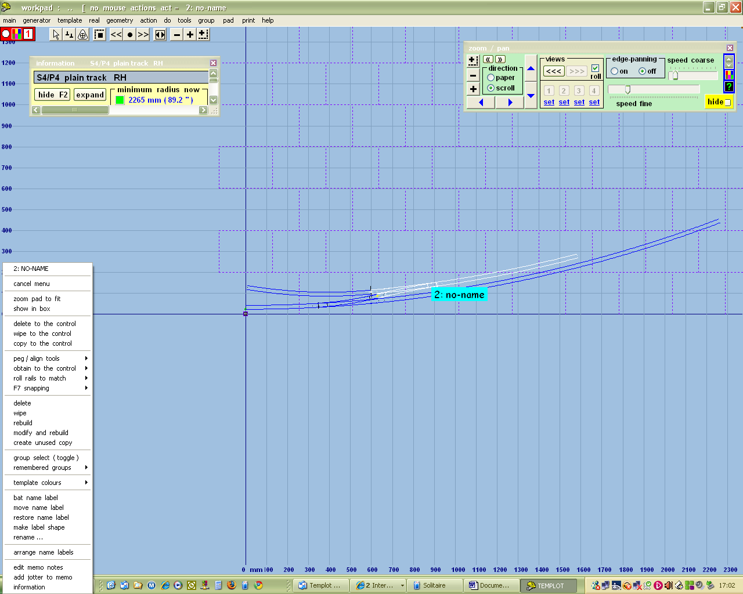

and then delete to the control. You may get another warning screen – click "OK don't tell me again"
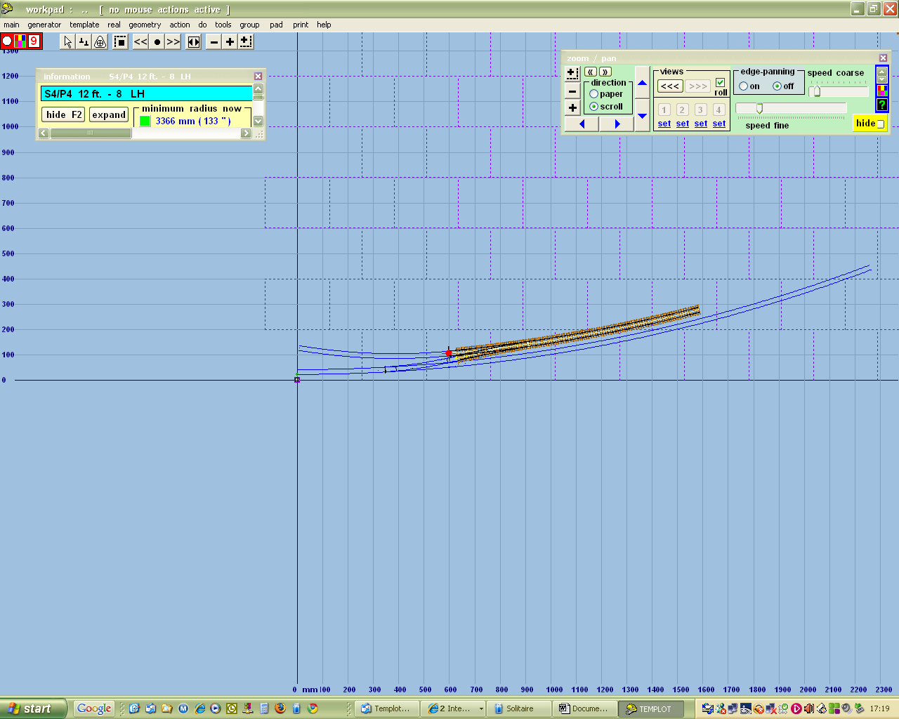

Now we can only have one turnout in any template, so I'm going to split off the approach track using tools / make split / make separate approach track, thus

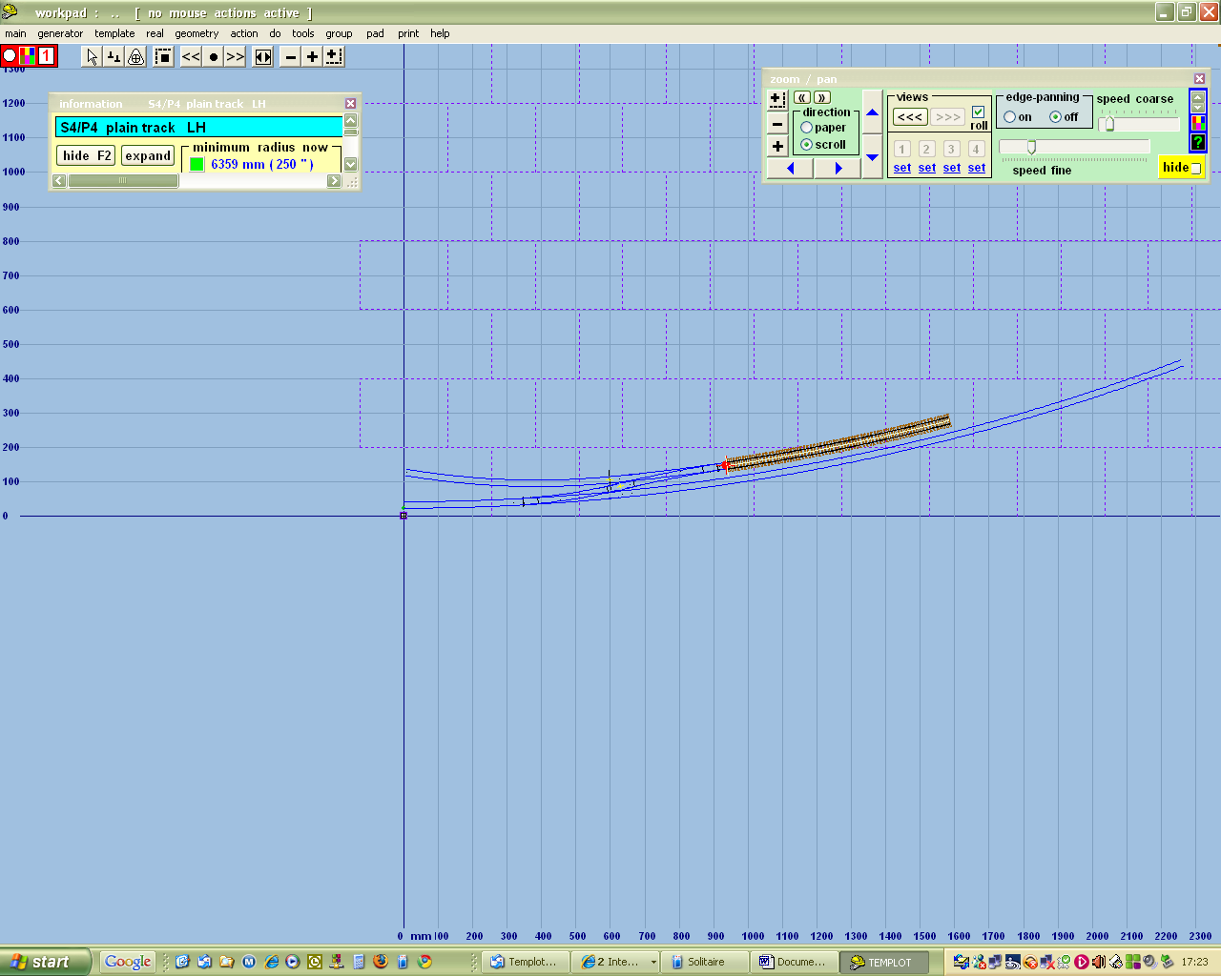

Now I'll put in a turnout into this template using template / insert turnout in plain track.

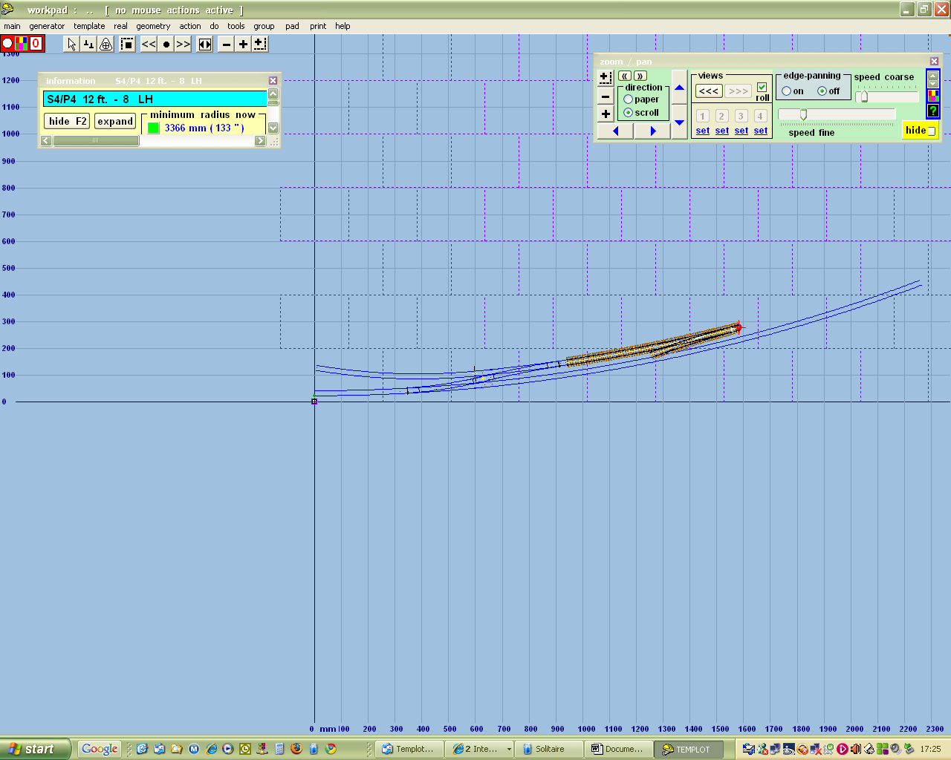

Notice that this template has the same specification as the previous one – 1:8 12ft straight heel switches. However it's pointing the wrong way. So click template / swap facing – trailing.

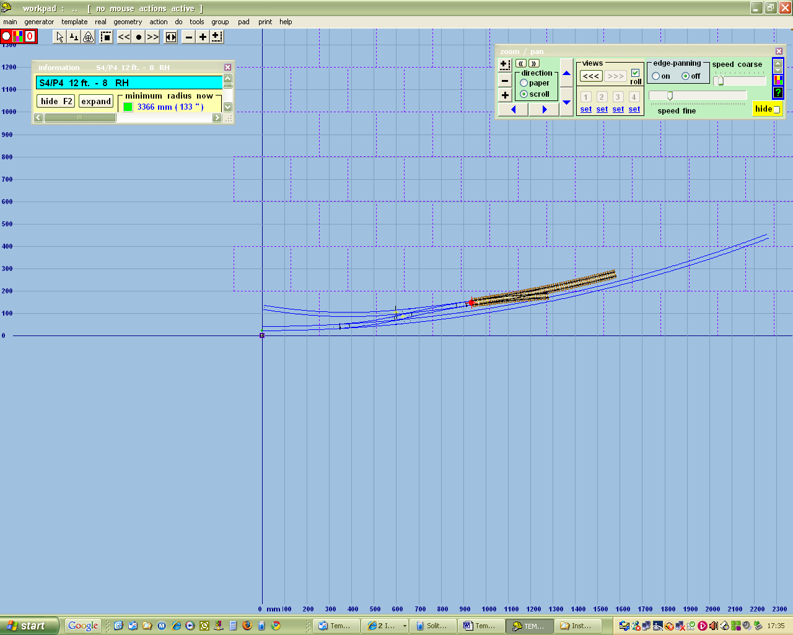

Now it's pointing the right way, but it isn't much of a loop, so we'll extend it by increasing the approach length F3

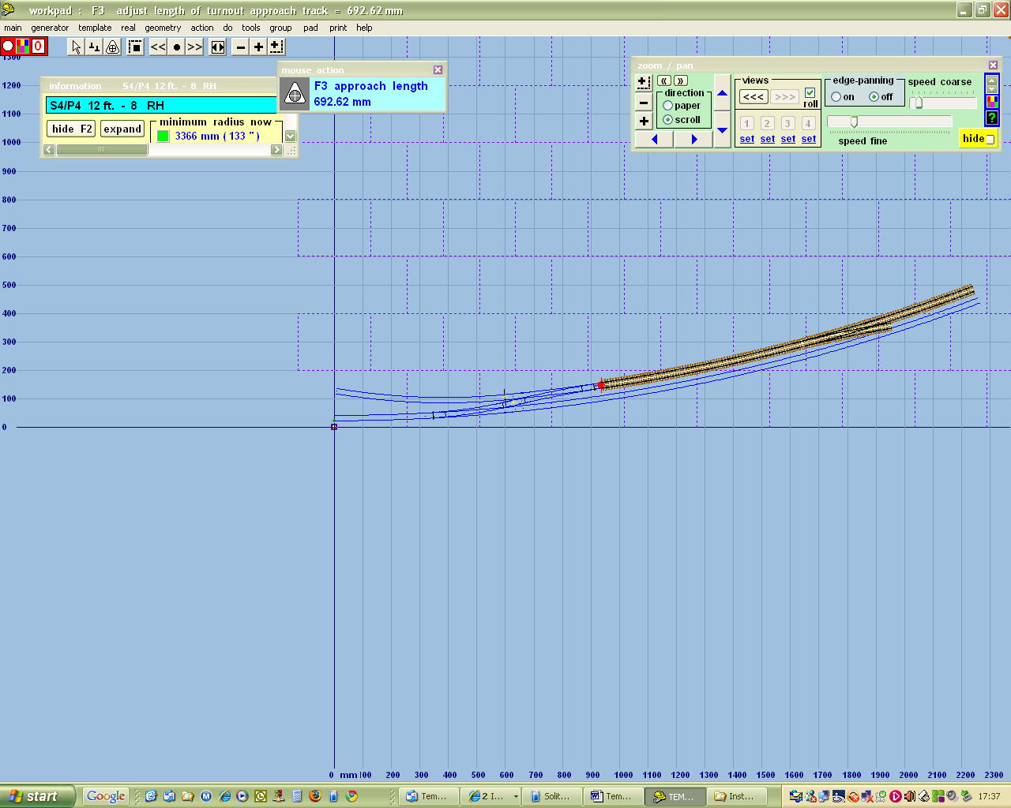

Now I just need to complete the crossover with tools / make simple crossover

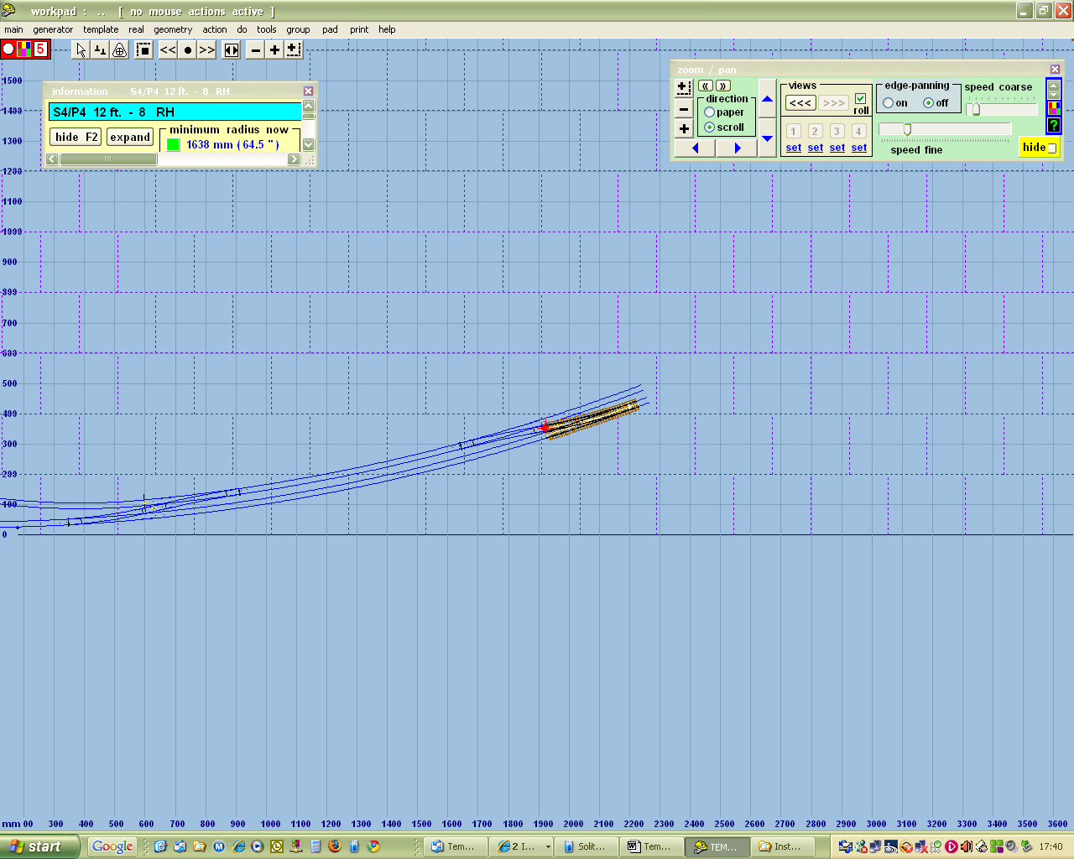

I can then extend the length of the approach road (F3), save and background, select the main line, delete to control, and shorten it to avoid overlapping templates

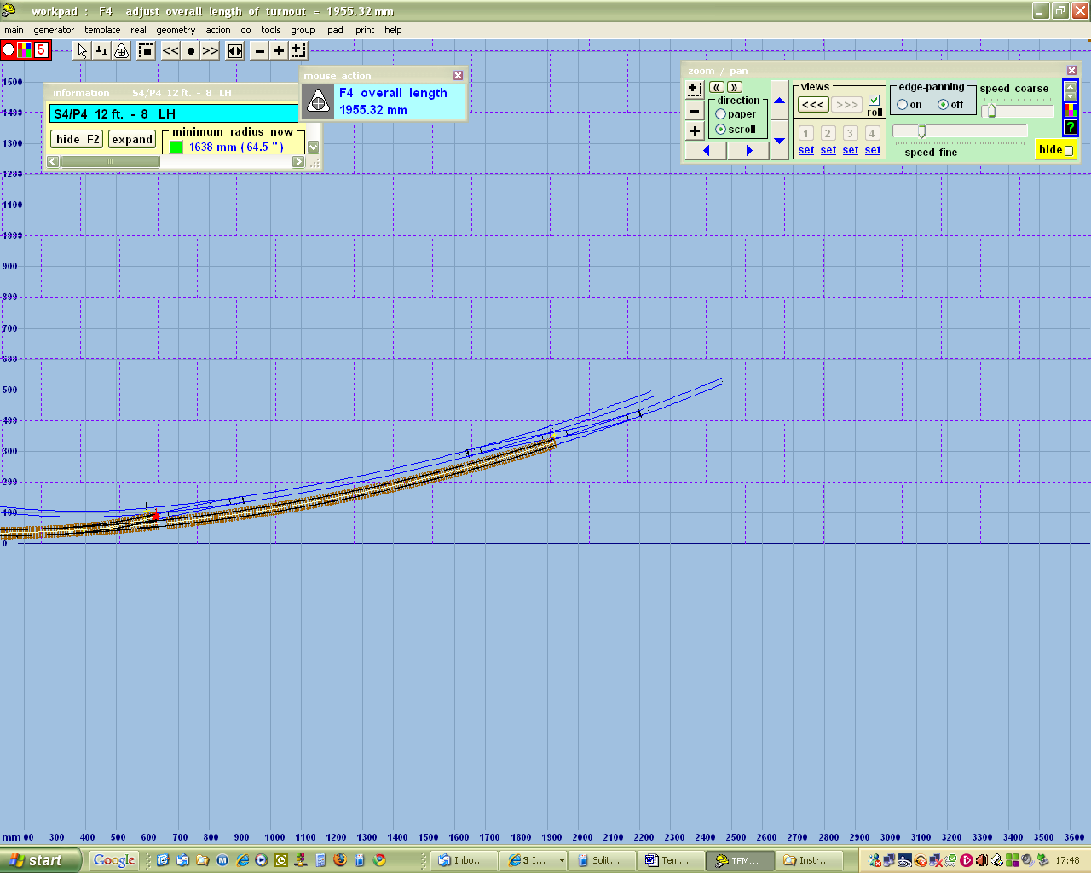

Now I want to add a siding off the loop, so I need to right click, save and background, select the loop line and delete to control

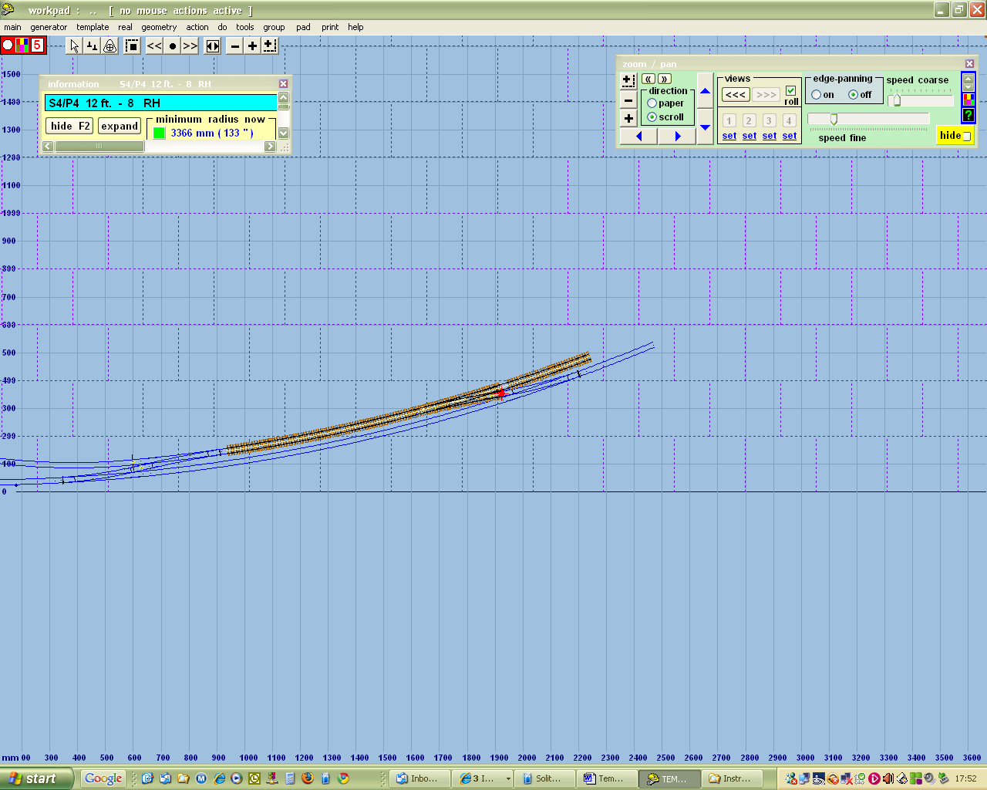

Again I need to split off the approach so tools / make split / make separate approach track

. 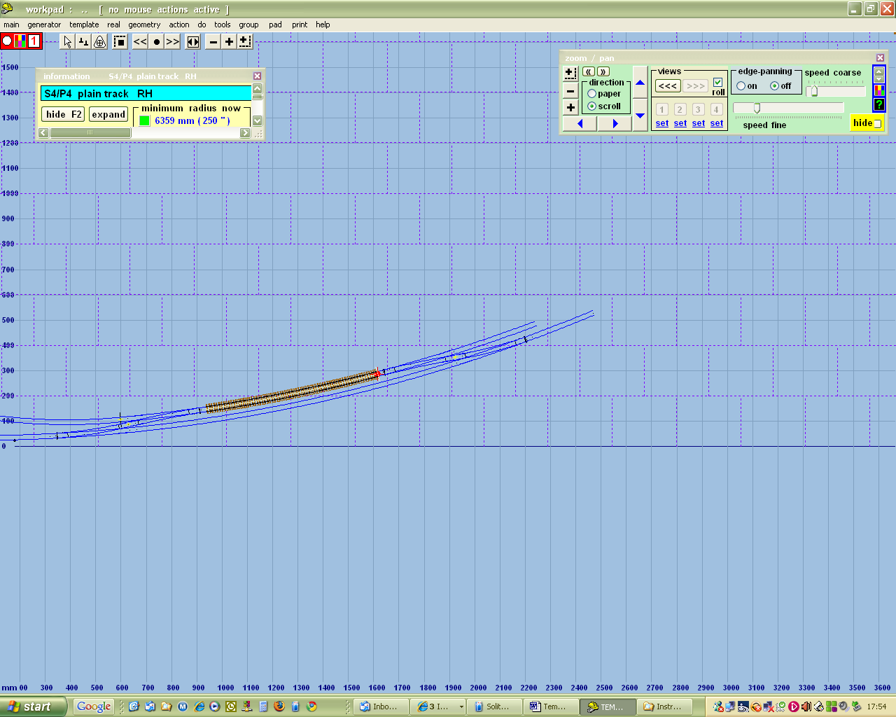

Now I can add the turnout template / insert turnout in plain track.

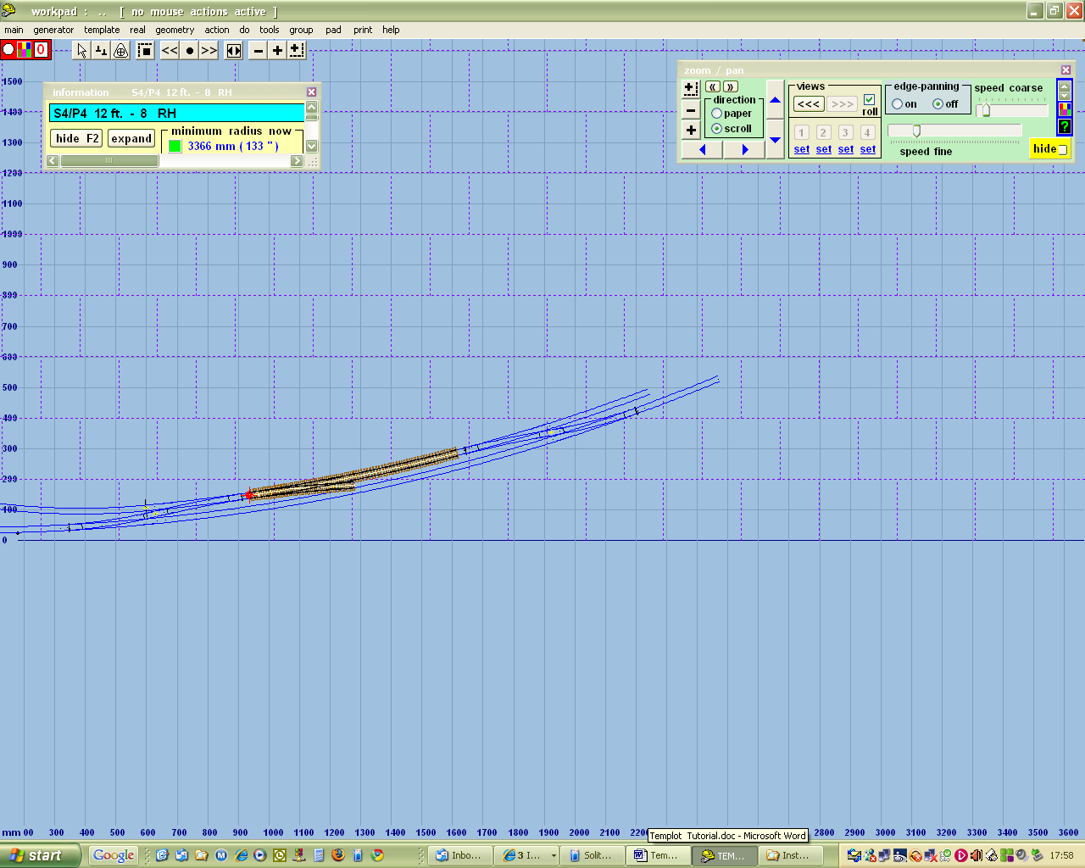

It's the wrong way round, so use template / swap facing/trailing, then template / invert handing to get it pointing in the right direction
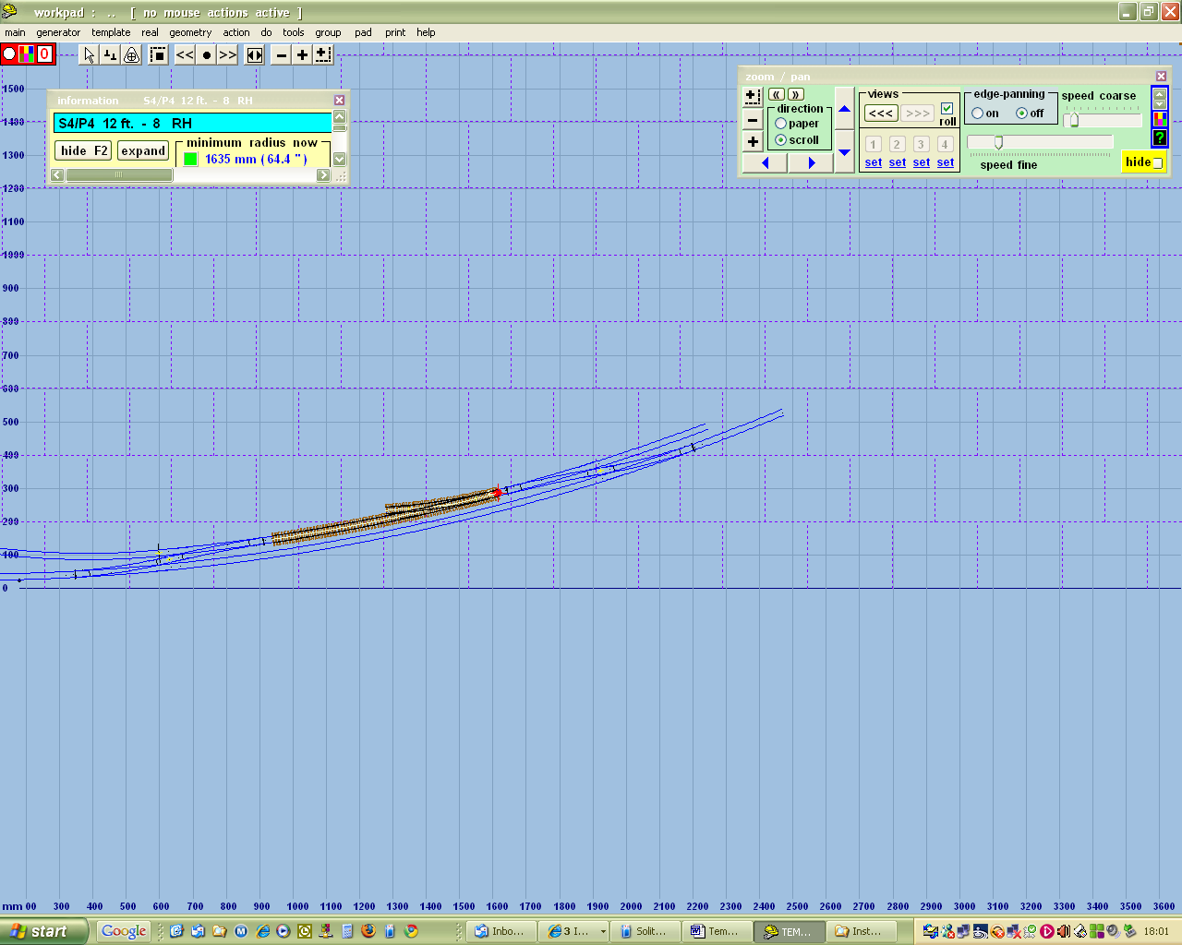

Now I want the siding to be further away from the running line, so set this in tools / adjacent track centres to 60mm

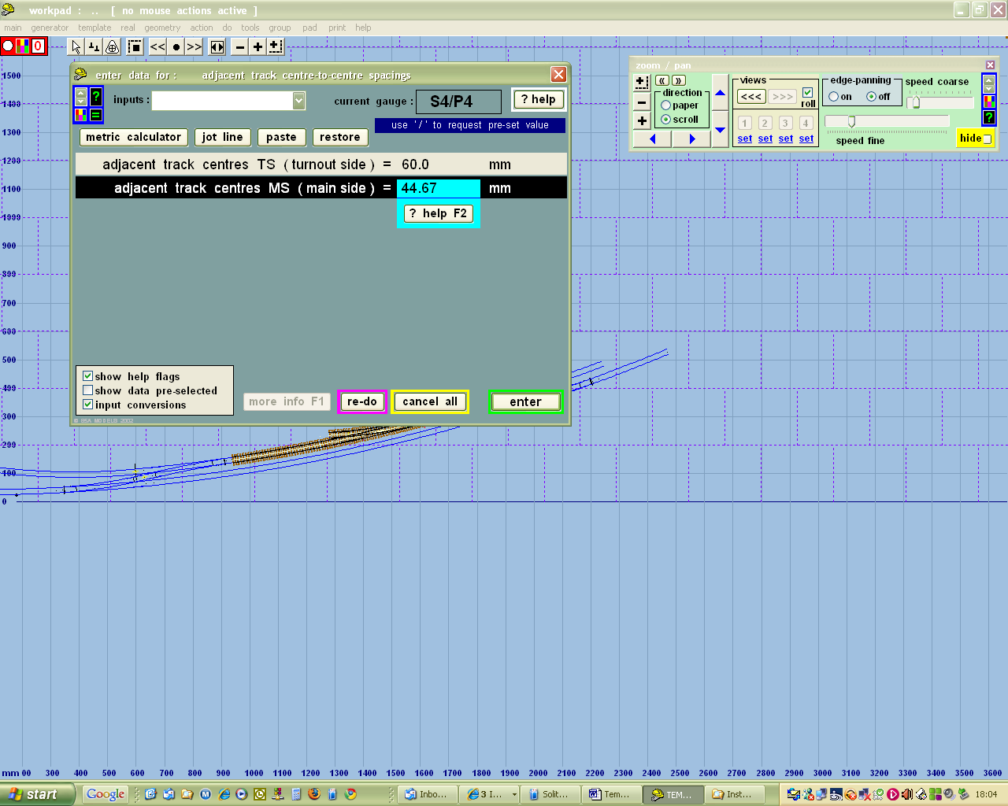

We only need to worry about the turnout side here. Now click tools / make return curve

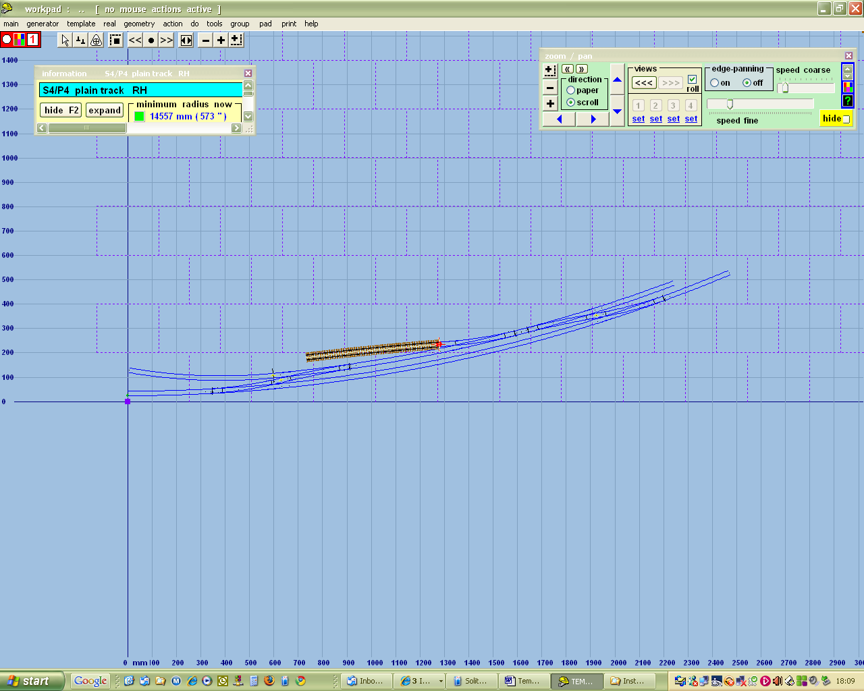

I want to use the notch to attach the next piece of track, so first move the peg to the other end, then press / on the numeric pad to put the notch under the peg

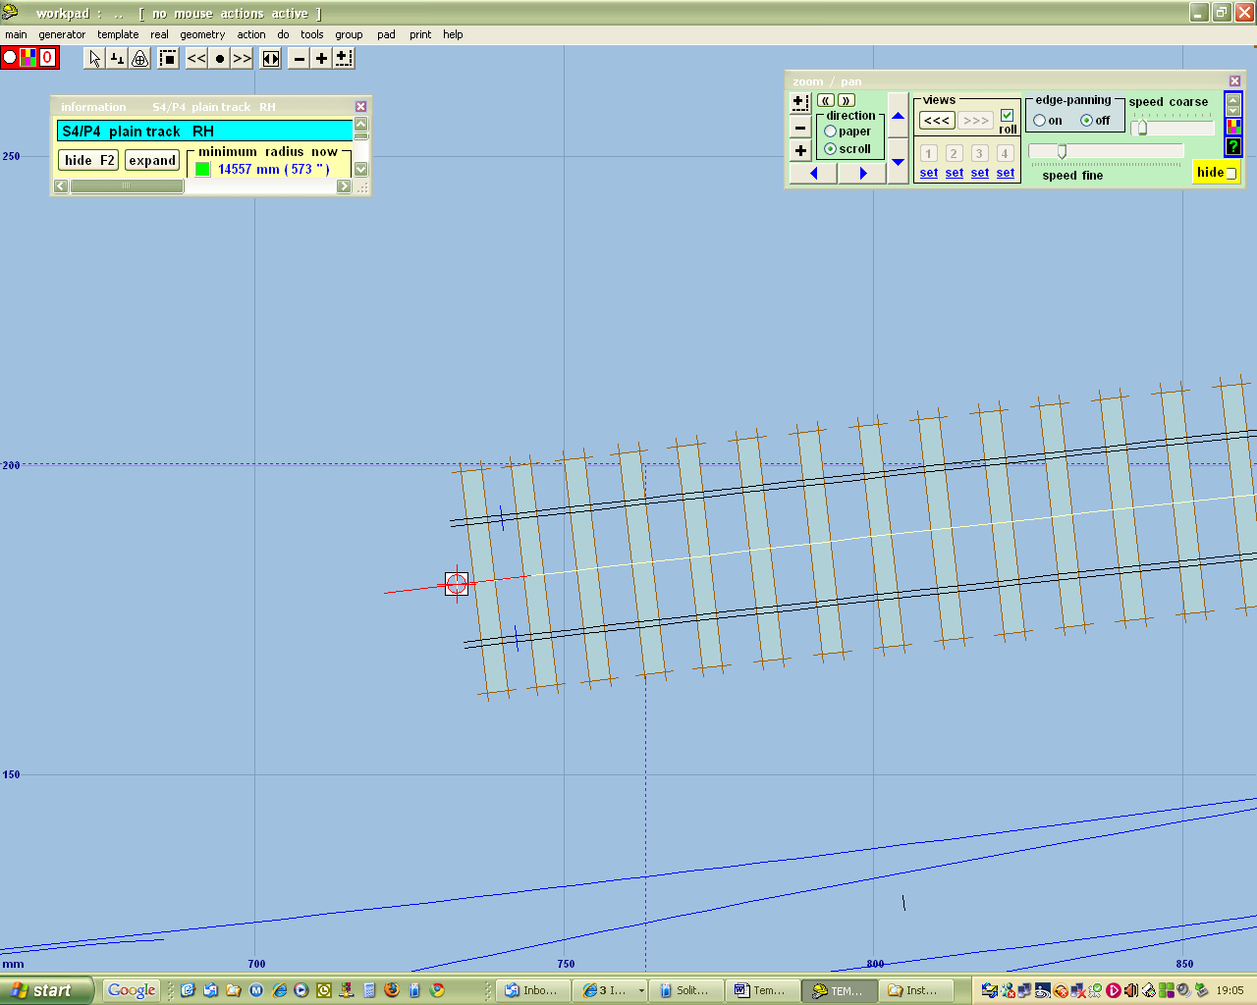

This is what it looks like when I zoom in.
Now store and background. Now I want to attach another bit of track to the end of the siding. To create this new bit of track, right click anywhere, then mint from control template, which gives me this.
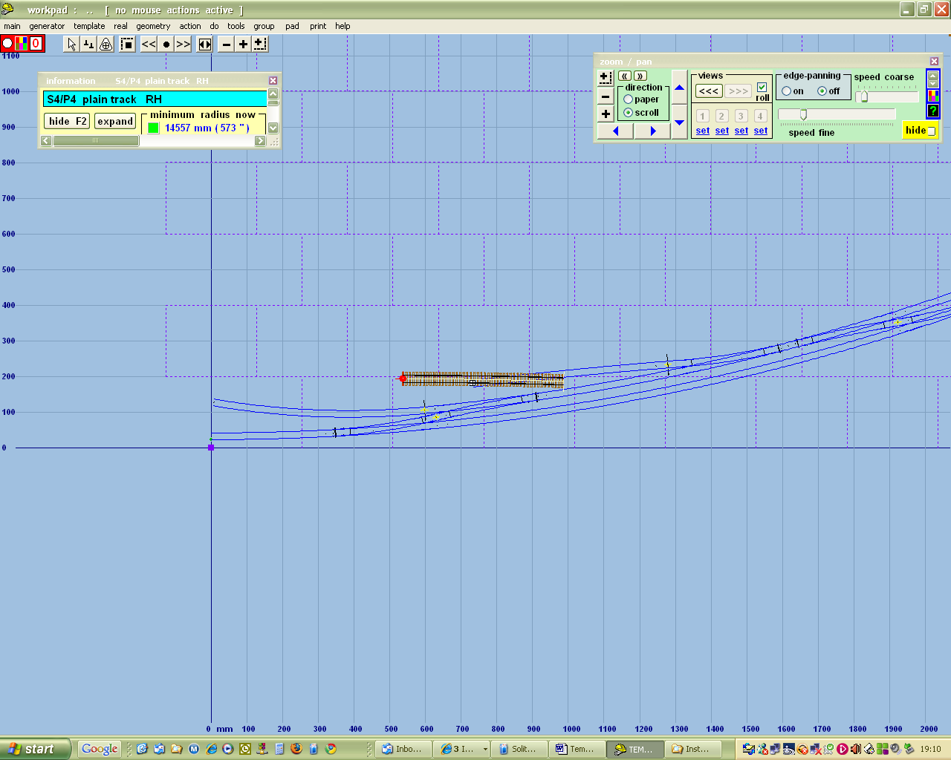

Move the peg to the other end

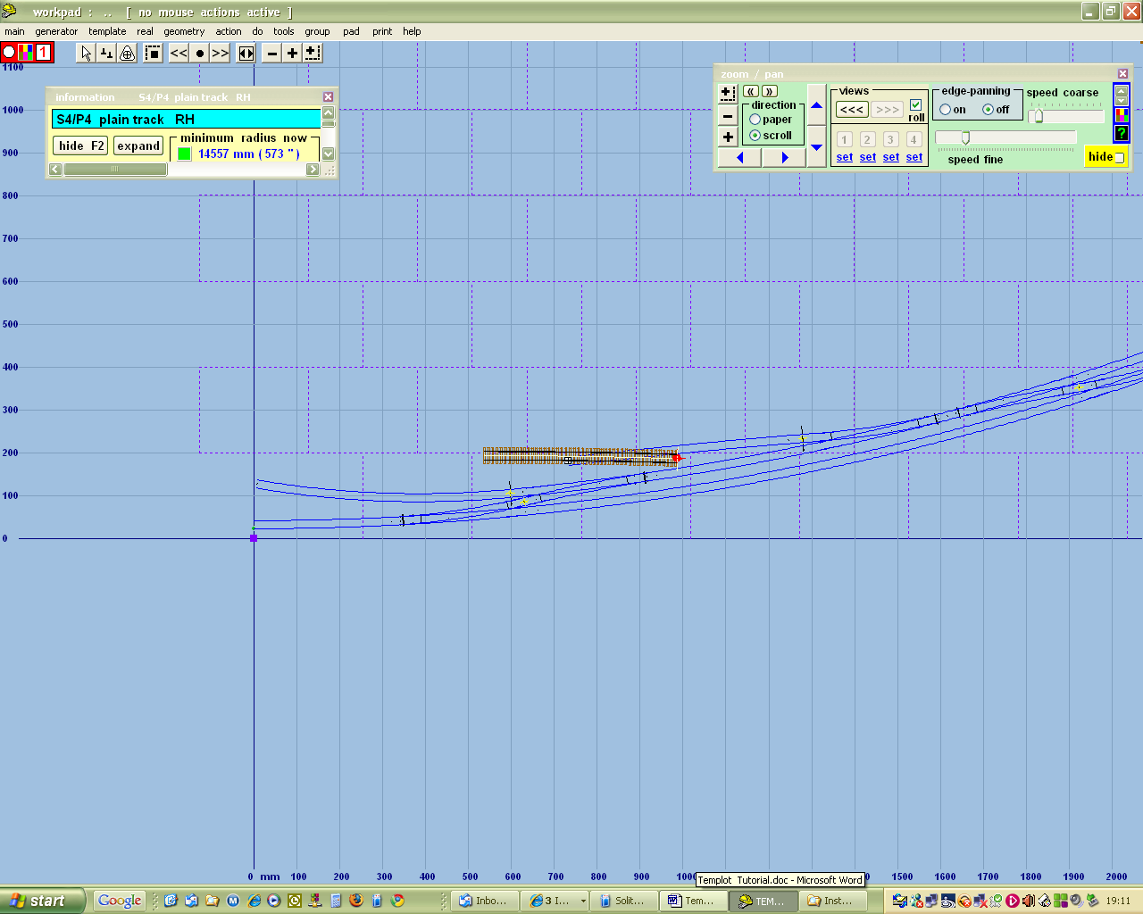

Then press * on numeric keypad and magically the new piece of track jumps onto the notch –- precisely aligned with the existing track
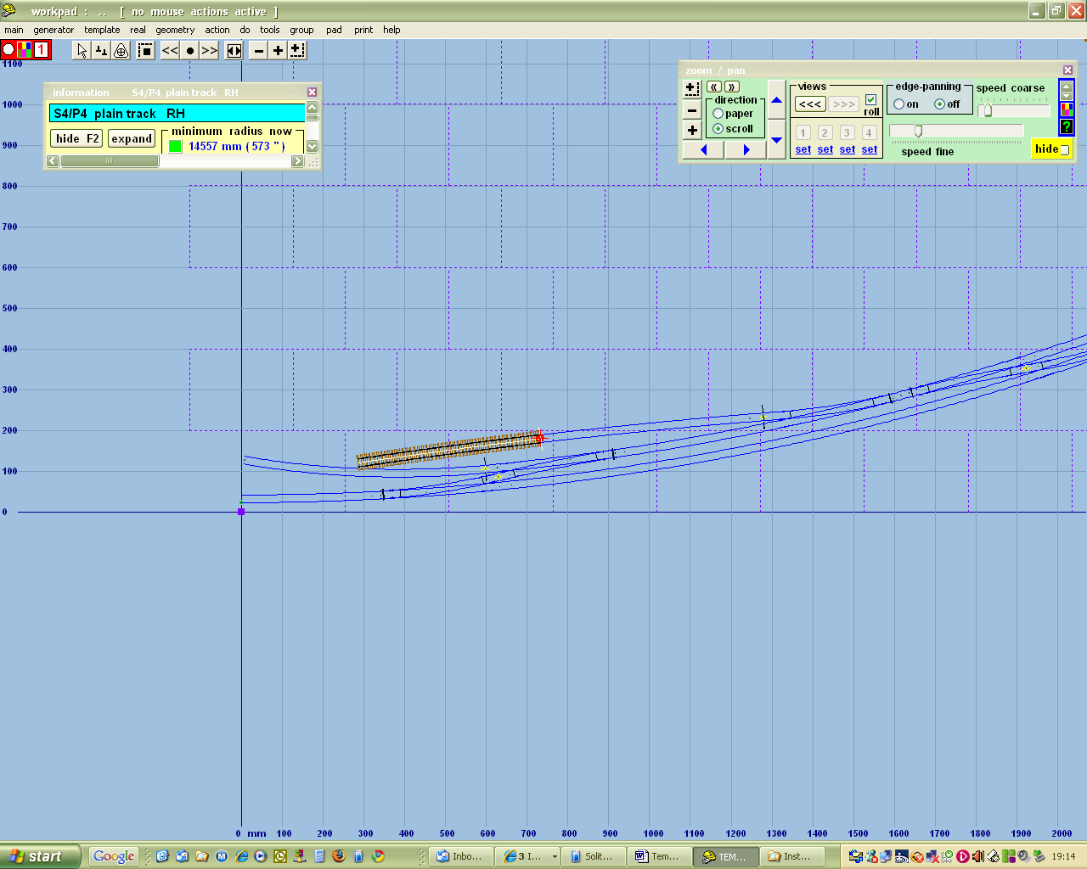

And I can now curve it and change the length as required

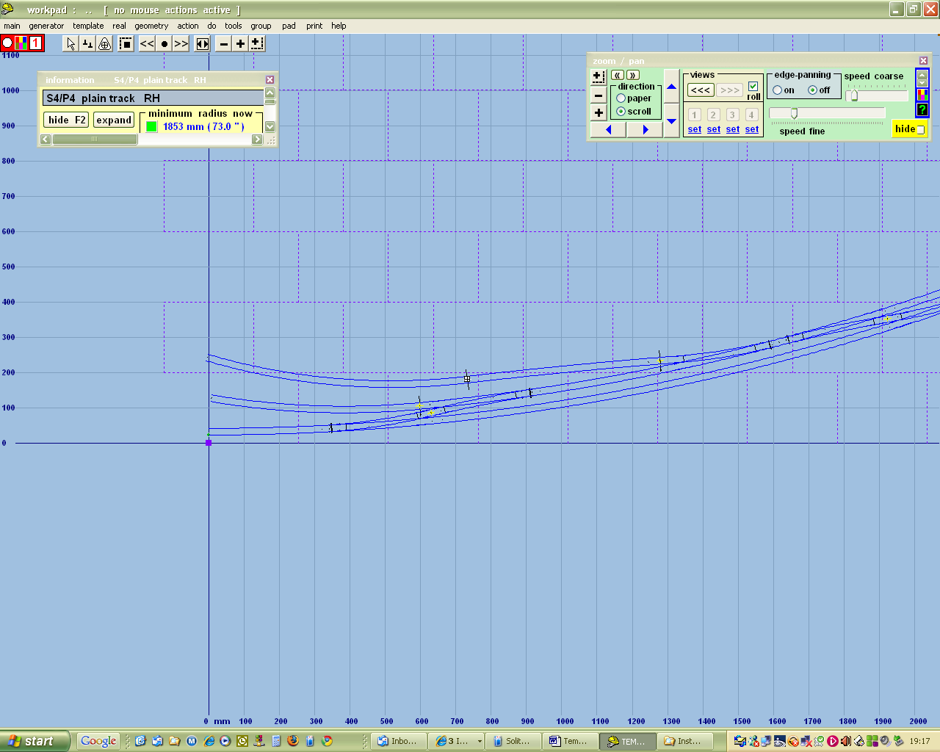

We have now created a piece of railway and can print off the whole plan at reduced scale, or individual pieces of track at full size for construction purposes. The dotted grid shows the outlines of A4 sheets if printing full size; the scale and the origins can be changed in the print menu

